MetAmino Kit®

Free (Physiological) Amino Acid and Metabolites GC-MS Analysis



User Manual
Ver. EN240208
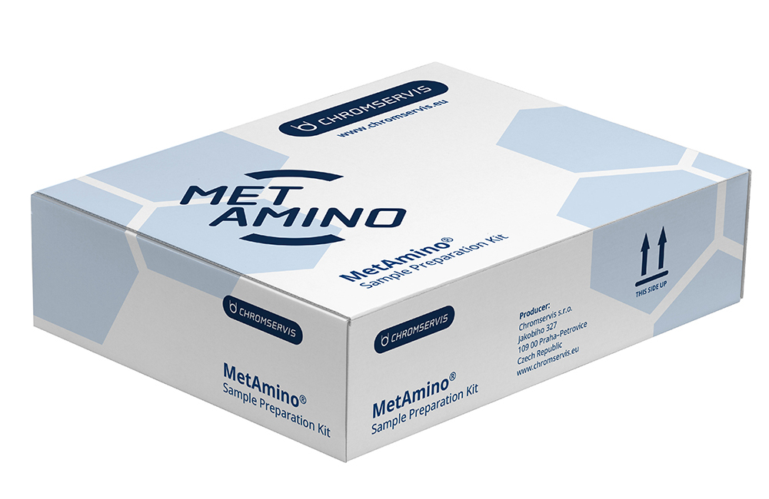

©Copyright Chromservis s.r.o. All rights reserved.

Important notes: Read this manual carefully before the product use. This product is intended for research use only. No responsibility will be accepted for the use in IVD (diagnostic) procedures.

Content of the Manual

1. Content of the Manual 2
2. Introduction 4
3. Kit Contents 4
3.1. Reagents, Liquid Media and Chemicals 4
3.2. Accessories 4
3.3. Materials and Tools 6
4. Overview 7
4.1. Method Description 7
4.2. Free Amino Acids in Biological Samples 8
4.3. Storage and Stability 11
4.4. Safety 12
5. Sample Preparation Procedure 13
5.1. Setup 13
5.2. Sample Preparation Protocol 13
5.2.1. Sample preparation step 13
5.2.2. Derivatization step 13
5.2.3. LLME step 14
5.3. Optimizing Sample Preparation Time 14
5.4. Column for MetAmino® GC-MS analysis 14
5.4.1. MetAmino® GC column conditioning 14
5.4.2. GC method 15
5.4.3. MS method 15
5.5. Tuning the Mass Spectrometer 15
5.6. Calibration Standards 15
5.7. Calibration Procedure 16
5.7.1. Extracted ion chromatograms 18
6. Sample Storage and Stability 29
7. Cleaning and Care of Supplies 29
8. Quality Assurance 29
9. Ordering Information 30
10. Safety Data Sheets 30
11. Warranty 30
12. Manufacturer Contact 31

Introduction
Thank you for purchasing the Chromservis MetAmino® Amino Acid and Metabolite Kit. This user manual provides information regarding the care and use of the sample preparation kit including the workflow protocol.

Kit Contents

Reagents, Liquid Media and Chemicals
The MetAmino® Start-up kit is designed for 100 samples. Reagents, liquid media and chemicals are included. The Basic kit (400 samples kit) includes two boxes:
- The Start-up kit (100 samples)
- Extended box (reagents, liquid media, chemicals and accessories for an additional 300 samples)

Item | Vial type | Volume in vial  (mL) | No. of vials (100 samples) | No. of vials (400 samples)
Amino Acid Standards SD1 Solution | 2 mL vial | 0.25 | 1 | 4
Amino Acid Standards SD2 Dried | 2 mL vial | n/a | 2 | 8
Solution with Internal Standard (IS) | 2 mL vial | 1.1 | 1 | 4
Amino Acid Standard Diluting Medium (AASDM) | 4 mL vial | 1.4 | 1 | 4
Reducing Agent (RA) | 4 mL vial | 2.75 | 1 | 4
Basic Medium (BM) | 4 mL vial | 2.75 | 1 | 4
Catalytic Solution (CTS) | 40 mL vial | 5.5 | 1 | 4
Reagent (Derivatization) Solution (RDS) | 40 mL vial | 5.5 | 1 | 4
Extraction Medium (EM) | 40 mL vial | 5.5 | 1 | 4
Acidic Medium (AM) | 4 mL vial | 2.75 | 1 | 4

Accessories
Item | Note | Amount (100 samples) | Amount (400 samples)
MetAmino® GC Column | Proprietary stationary phase | 1 pc | 1 pc
Reaction glass tubes |  | 100 pcs | 400 pcs
Tube rack for up to 80 reaction Tubes | See Fig. 3 in Section 5.1 | 1 pc | 1 pc
Autosampler Vials (9 mm screw-top) | Including septa and caps | 100 pcs | 400 pcs
Inserts for Autosampler Vials |  | 100 pc | 400 pc

Figure 1 - MetAmino® start-up kit for 100 samples
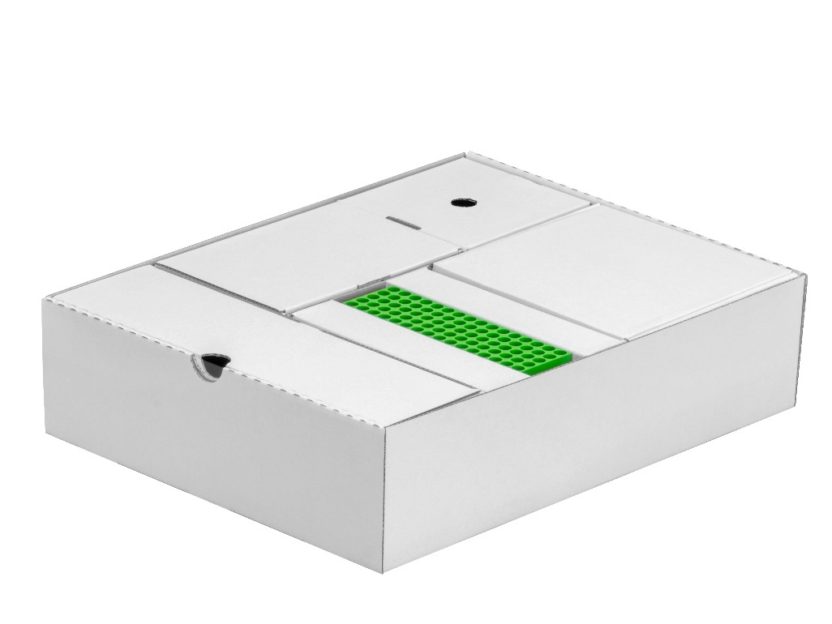
Box with Standards and Reagents (See Figure 4)
Box with Reaction glass tubes and Autosampler vial caps (below the box with Chromatography Column)
Autosampler vials (below the box with Tube rack)
Box with Reaction glass tubes
Tube rack
Box with Chromatography Column

Box with Autosampler vials and caps in 400 sample kit, otherwise empty

Figure 2 - MetAmino® extended box for a further 300 samples
Box with additional labware
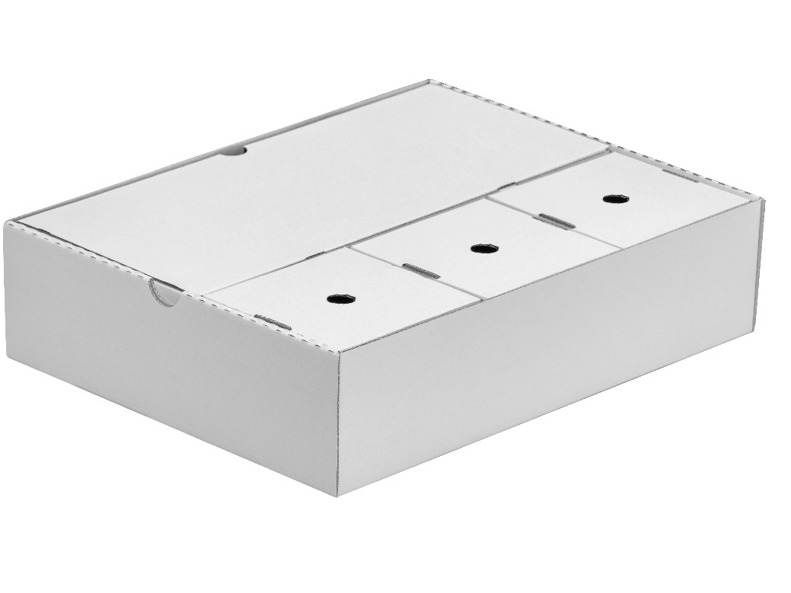
Box 2 with Standards and Reagents
Box 3 with Standards and Reagents
Box 1 with Standards and Reagents

Materials and Tools
All items listed below are necessary for the workflow. These items are NOT included and supplied with the MetAmino® kit.

No. | Material/Tool
1 | Pipette 10 µL to 100 µL
2 | Pipette 100 µL to 1000 µL
3 | Pipette tips
4 | Vortex
5 | Bench-top microcentrifuge capable 6000 rpm (min 1500 g)
6 | Pasteur pipettes for sample transfer (see section 5.2 step 9)
7 | Container for proper waste disposal

Overview

Method Description
The MetAmino® kit is designed for the comprehensive analysis of amino acids, biogenic amines and other metabolic analytes by gas chromatography-mass spectrometry (GC-MS) using various mass spectrometric detectors (quadrupole, triple quadrupole). The method has been validated for the determination of 21 amino acids and related compounds with primary or secondary amino groups in human serum and urine. The MetAmino® acid analysis procedure consists of a derivatization followed by liquid/liquid microextraction (LLME) step; derivatized samples are quickly analyzed by gas chromatography-mass spectrometry. Analytes are quickly derivatized with reagent at room temperature in aqueous solution. Derivatized analytes concomitantly migrate to the organic layer for additional separation from interfering compounds. Organic layer is then directly amenable for GC/MS system.
The analytical procedure using the MetAmino® kit consists of the following steps:
- In-situ derivatization of the amino functional groups
- Liquid/liquid microextraction (LLME)

The GC-MS analysis runs on a MetAmino® GC column. Sample preparation time takes around 5 minutes. GC-MS analysis is accomplished in 12 minutes. Total analysis time is around 17 minutes.

The MetAmino® kit video is provided to facilitate familiarization and to demonstrate the simplicity of the described procedure. Please note that some of the sample preparation steps described in the video may be slightly different than described in this User Manual. The MetAmino® kit video can serve as a general User Manual. The whole MetAmino® kit is described in detail in this User Manual.

Free Amino Acids in Biological Samples
The MetAmino® method has been developed for the GC-MS analysis of more than 70 amino acids and related compounds. For the complete list, please refer to Table 1a and Table 1b. However, the amino acid set can further be expanded to other compounds containing primary or secondary amino functional groups. If other analytes are a subject of the extended application, please contact your Chromservis technical consultant for assistance.
Table 1a Comprehensive list of amino acids and related compounds prepared by MetAmino® kit for GC-MS analysis (amino acid standards of SD1 and SD2 are in italic, and the included internal standards are highlighted in bold)
 | Analyte |  | RT | Mmi* | Diagnostic ions
No. | Name | Synonyms | [min] |  | m/z | m/z | m/z
1 | Sarcosine | SAR | 2.36 | 497.0308 | 270 | 226 | 69
2 | Alanine | ALA | 2.50 | 497.0308 | 270 | 70 | 69
3 | 3,3,3,D3-DL Alanine | IS | 2.61 | 501.0409 | 273 | 73 | 113
4 | N-Acetylglycine |  | 2.65 | 299.0392 | 256 | 113 | 212
5 | Glycine | GLY | 2.68 | 483.0151 | 256 | 212 | 56
6 | 3-Methylglutaric acid |  | 2.74 | 510.0512 | 311 | 282 | 227
7 | 2-Aminobutyric acid | 2-ABA | 2.90 | 511.0465 | 284 | 84 | 113
8 | 3-Hydroxymethylglutaric acid |  | 2.95 | 752.0325 | 285 | 311 | 85
9 | N-Acetylcysteine |  | 3.00 | 571.0134 | 282 | 309 | 509
10 | beta-Alanine | 3-ALA | 3.03 | 497.0308 | 269 | 256 | 98
11 | Valine | VAL | 3.03 | 525.0621 | 298 | 283 | 98
12 | β-Aminoisobutyric acid | BAIBA | 3.11 | 511.0465 | 256 | 112 | 113
13 | 3-Amino-n-butyric acid | 3-ABA | 3.06 | 511.0465 | 270 | 227 | 283
14 | Norvaline | NVA | 3.25 | 525.0621 | 298 | 256 | 98
15 | Leucine | LEU | 3.42 | 539.0778 | 312 | 270 | 256
16 | allo-Isoleucine | aILE | 3.43 | 539.0778 | 312 | 283 | 256
17 | Ethanolamine | ETA | 3.47 | 513.0257 | 256 | 269 | 270
18 | Isoleucine | ILE | 3.48 | 539.0778 | 283 | 312 | 256
19 | Homoserine | HSER | 3.48 | 753.0278 | 100 | 283 | 128
20 | Proline | PRO | 3.53 | 523.0465 | 296 | 297 | 69
21 | Threonine | THR | 3.67 | 527.0415 | 100 | 283 | 483
22 | 4-Aminobutyric acid | GABA | 3.67 | 511.0465 | 112 | 256 | 69
23 | Norleucine | NLE | 3.70 | 539.0778 | 312 | 256 | 112
24 | Pipecolic acid | PIP | 3.72 | 537.0621 | 310 | 518 | 407
25 | N-Acetylaspartic acid |  | 3.75 | 539.0414 | 270 | 312 | 228
26 | Asparagine | ASN | 3.79 | 522.0261 | 295 | 496 | 113
27 | Thioproline | TPR | 4.06 | 541.0029 | 314 | 287 | 86
28 | 2-Hydroxyglutaric acid |  | 4.07 | 738.0169 | 283 | 239 | 511
29 | Aspartic acid | ASP | 4.10 | 723.0173 | 254 | 496 | 296
30 | 3-Methylcysteine |  | 4.17 | 543.0185 | 61 | 300 | 316
31 | Serine | SER | 4.40 | 739.0122 | 268 | 295 | 51
32 | Acetylserine |  | 4.42 | 555.0363 | 268 | 312 | 113
33 | Pyroglutamic acid |  | 4.61 | 537.0000 | 282 | 310 | 510
34 | N-Acetylglutamic acid |  | 4.69 | 567.0727 | 282 | 310 | 510
35 | Glutamic acid | GLU | 4.70 | 737.0329 | 282 | 310 | 510
36 | Methionine | MET | 4.64 | 557.0342 | 283 | 483 | 357
37 | 4-Hydroxyproline | 4-HYP | 4.61 | 539.0414 | 312 | 294 | 68
38 | Cysteine | CYS | 4.99 | 754.9895 | 328 | 285 | 113
39 | Selenomethionine |  | 4.93 | 604.9786 | 282 | 510 | 405
40 | Ethionine | ETH | 4.95 | 571.0498 | 282 | 311 | 571
41 | Phenylalanine | PHE | 5.09 | 573.0621 | 91 | 330 | 92
42 | 2-Aminoadipic acid | AAA | 5.20 | 751.0486 | 124 | 282 | 324
43 | 3-Hydroxyproline | 3-HYP | 4.45 | 539.0414 | 312 | 129 | 256
44 | 2,4-Diaminobutyric acid | DABA | 5.48 | 752.0438 | 282 | 256 | 325
45 | S-Carboxymethyl-cysteine |  | 5.52 | 769.0050 | 213 | 259 | 314
46 | Homocysteine | HCYS | 5.56 | 769.0045 | 282 | 342 | 82
47 | 2-Aminopimelic acid | APA | 5.61 | 765.0642 | 338 | 138 | 95
48 | Histamine | HTA | 5.64 | 563.0526 | 308 | 320 | 113
49 | Homophenylalanine | IS | 5.69 | 587.0778 | 283 | 117 | 483
50 | Glutamine | GLN | 5.73 | 554.0523 | 84 | 282 | 327
51 | 4-Aminobenzoic acid | PABA | 5.87 | 545.0308 | 146 | 345 | 346
52 | 1-Methylhistidine |  | 5.89 | 577.0682 | 95 | 150 | 350
53 | Chloro-phenylalanine |  | 5.91 | 607.0231 | 125 | 364 | 180
54 | Methionine sulfone | MET-SO₂ | 5.99 | 589.0240 | 282 | 82 | 189
55 | Ornithine | ORN | 6.09 | 766.0595 | 296 | 256 | 69
56 | Acetyltyrosine |  | 6.15 | 871.0489 | 333 | 289 | 188
57 | Histidine | HIS | 6.28 | 789.0391 | 307 | 362 | 113
58 | Glycylproline | GPR | 6.36 | 580.0679 | 70 | 153 | 296
59 | Lysine | LYS | 6.46 | 780.0751 | 310 | 256 | 153
60 | Tyramine |  | 6.48 | 589.0570 | 346 | 333 | 289
61 | 2,6-Diaminopimelic acid (isomers) |  | 6.93 | 1006.0616 | 308 | 536
62 | Tyrosine | TYR | 6.95 | 815.0435 | 333 | 289 | 113
63 | 5-Hydroxylysine (isomers) | 5-HLY | 7.17 | 1022.0565 | 269 | 256 | 69
64 | Cystathionine | CTH | 7.57 | 1038.0337 | 328 | 282 | 69
65 | Dopamine | DAM | 7.52 | 831.0000 | 256 | 531 | 113
66 | Tryptophan | TRP | 7.49 | 612.0730 | 130 | 131 | 385
67 | 3,4-Dihydroxyphenylalanine | DOPA | 7.73 | 1057.0249 | 149 | 531 | 575
68 | Cystine | C-C | 7.78 | 1055.9901 | 496 | 268 | 113
69 | Prolylhydroxyproline | PHP | 7.84 | 862.0806 | 296 | 297 | 294
70 | 3-Nitrotyrosine |  | 7.95 | 860.0286 | 334 | 113 | 378

* Mmi = monoisotopic mass of the derivative of the relevant metabolite fragmentation in ion source
Table 1b Comprehensive MRM transitions of amino acids and related compounds prepared by MetAmino kit for GC-MS analysis (amino acid standards of SD1 and SD2 are in italic, and the included internal standards are highlighted in bold)
 | Analyte |  | MRM MS/MS transitions
No. | Name | Synonyms | Quantifier ª (CE^{b}) | Qualifier^{c} (CE) | Qualifier (CE)
2 | Alanine | ALA | 270 ˃ 113 (20) | 270 ˃ 226 (20) | 113 ˃ 69 (20)
5 | Glycine | GLY | 256 ˃ 113 (20) | 212 ˃ 73 (20) | 212 ˃ 192 (10)
11 | Valine | VAL | 298 ˃ 55 (20) | 283 ˃ 83 (10) | 298 ˃ 98 (10)
15 | Leucine | LEU | 312 ˃ 256 (10) | 256 ˃ 113 (20) | 312 ˃ 113 (20)
18 | Isoleucine | ILE | 312 ˃ 256 (10) | 283 ˃ 83 (20) | 312 ˃ 113 (20)
29 | Aspartic acid | ASP | 296 ˃ 96 (10) | 296 ˃ 254 (10) | 496 ˃ 454 (20)
20 | Proline | PRO | 296 ˃ 113 (30) | 296 ˃ 70 (30) | 504 ˃ 296 (30)
21 | Threonine | THR | 100 ˃ 50 (30) | 100 ˃ 69 (30) | 283 ˃ 83 (10)
26 | Asparagine | ASN | 295 ˃ 113 (20) | 95 ˃ 68 (10) | 295 ˃ 95 (20)
31 | Serine | SER | 295 ˃ 113 (10) | 268 ˃ 240 (20) | 268 ˃ 113 (20)
35 | Glutamic acid | GLU | 282 ˃ 82 (10) | 282 ˃ 113 (20) | 310 ˃ 282 (10)
37 | trans-4-L-Hydroxyproline | 4-HYP | 294 ˃ 94 (20) | 294 ˃ 113 (30) | 521 ˃ 294 (10)
36 | Methionine | MET | 283 ˃ 83 (20) | 483 ˃ 283 (10) | 483 ˃ 83 (20)
38 | Cysteine | CYS | 285 ˃ 213 (30) | 328 ˃ 101 (20) | 328 ˃ 113 (20)
41 | Phenylalanine | PHE | 91 ˃ 65 (30) | 330 ˃ 131 (20) | 330 ˃ 103 (30)
57 | Histidine | HIS | 307 ˃ 113 (20) | 362 ˃ 135 (20) | 307 ˃ 236 (20)
59 | Lysine | LYS | 256 ˃ 113 (20) | 310 ˃ 113 (30) | 256 ˃ 192 (10)
50 | Glutamine | GLN | 327 ˃ 84 (10) | 327 ˃ 282 (10) | 282 ˃ 82 (20)
62 | Tyrosine | TYR | 333 ˃ 289 (20) | 333 ˃ 113 (20) | 289 ˃ 107 (20)
63 | 5-Hydroxylysine (isomers) | 5-HLY | 269 ˃ 86 (10) | 269 ˃ 113 (20) | 256 ˃ 113 (20)
66 | Tryptophan | TRP | 130 ˃ 77 (30) | 130 ˃ 103 (30) | 130 ˃ 51 (30)
3 | 3,3,3,D3-DL Alanine | IS | 273 ˃ 113 (20) | 273 ˃ 229 (20)
49 | Homophenylalanine | IS | 91 ˃ 65 (30) | 283 ˃ 83 (10) | 283 ˃ 113 (20)

ª Quantifier ion transition (Optimized for Agilent 6495B)
^{b} Collision energy (Optimized for Agilent 6495B)
^{c} Qualifier ion transition (Optimized for Agilent 6495B)

Storage and Stability
Amino Acid Standards SD1 are supplied in the solution and Amino Acid Standards SD2 are supplied in dried form. The standard stock solution SD2 should be used as freshly prepared on the day of consumption. We recommend storing the complete Box with Standards and Reagents at 4 °C in the dark.
Table 2 Overview of the stability of the standards and reagents contained in the MetAmino® kit
Item | Storage conditions | Stability
Amino Acid Standards SD1 Solution | 4 °C | 12 months
Amino Acid Standards SD2 Dried | 4 °C | 12 months
Solution with Internal Standard (IS) | 4 °C | 12 months
Amino Acid Standard Diluting Medium (AASDM) | 4 °C | 12 months
Reducing Agent (RA) | 4 °C | 12 months
Basic Medium (BM) | 4 °C | 12 months
Catalytic Solution (CTS) | 4 °C | 12 months
Reagent (Derivatization) Solution (RDS) | 4 °C | 6 months
Extraction Medium (EM) | 4 °C | 12 months
Acidic Medium (AM) | 4 °C | 12 months

Safety
For safety reasons, the sample preparation station should be placed in a fume hood and protective gloves and goggles should be worn. When working with biological fluids, please take any necessary precautions to prevent infection with blood borne pathogens. Appropriate bio-safety precautions and disposal of bio-hazardous wastes should be followed. Follow the national standards and rules in your country.

Sample Preparation Procedure

Setup
The MetAmino® kit package was designed to be an efficient workstation. It contains a Reagent tray, Tube rack, and vial section. To speed up and simplify the sample preparation, it is recommended to use the Tube rack (See Figure 3). If the kit will not be used for several days, the Reagent tray (See Figure 4) can be conveniently removed and placed in the refrigerator at 4 °C.

Figure 3 – Tube rack Figure 4 – Box with Reagents and Standards
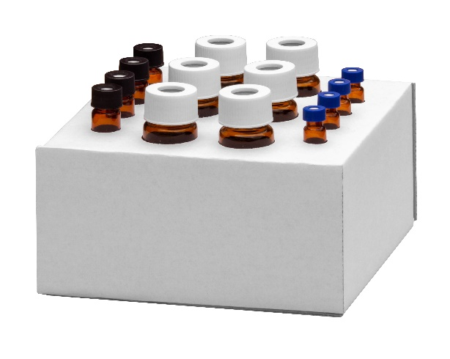
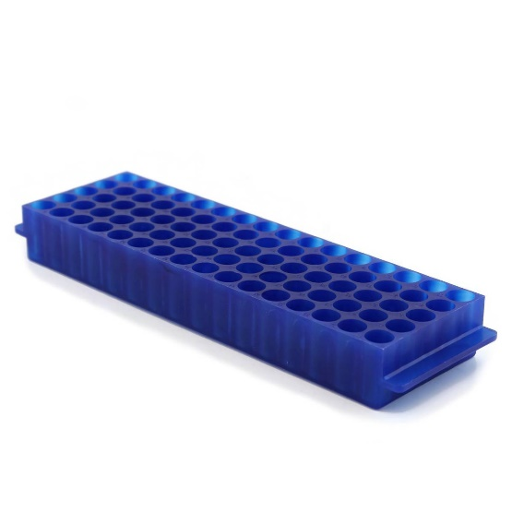

Sample Preparation Protocol
Note: The sample preparation process should be performed in a well-ventilated area (fume hood). The centrifugation steps require the sample to pass the membrane fluently and completely. We recommend spinning at 6,000 rpm
(1,500 ×g).

Sample preparation step
For each sample line up use one reaction glass tube.
STEP 1: Pipette 25 μL of sample (serum, plasma, urine or other), and 10 μL of solution with Internal Standards (IS) into each reaction glass tube.
Note: If low concentrations of analytes need to be quantified, the volume of sample to be prepared should be
50 μL or more.

Derivatization step
STEP 2: Pipette 20 μL of Reducing Agent (RA), into each reaction glass tube and vortex briefly (5 to 10 sec) and let it stand for 1 to 2 minutes.

Note: For all subsequent sample preparation steps use a vortex mixer set in the touch (pulse) mode (to about 80 % of max speed) for any mixing operations.

STEP 3: Pipette 25 μL of Basic Medium (BM) into each reaction glass tube
STEP 4: Pipette 50 μL of Reagent (Derivatization) Solution (RDS) into each reaction glass tube and vortex briefly (5 to 10 sec).
STEP 5: Pipette 25 μL of Catalytic Solution (CTS) into each reaction glass tube and vortex briefly (5 to 10 sec).
STEP 6: Pipette again 25 μL of Catalytic Solution (CTS) into each reaction glass tube and vortex briefly (5 to 10 sec) and let it stand for 1 to 2 minutes. The emulsion will gradually separate into two layers.
Note: A longer time than 2 minute each at steps 4 and 5, or later, at step 6, it does NOT have an influence on the analytical results.

LLME step
STEP 7: Pipette 50 μL of Extraction Medium (EM) into each reaction glass tube and vortex briefly (5 to 10 sec).
STEP 8: Pipette 25 μL of Acidic Medium (AM) into each reaction glass tube and vortex briefly (5 to 10 sec) and centrifuge 30 to 60 sec. at 1,500 ×g (6,000 rpm).
STEP 9 : Transfer the organic (upper) layer (50-100 µL) into the autosampler vial with insert. The sample is ready for GC-MS analysis.

Optimizing Sample Preparation Time
After a short period of practice the complete sample preparation protocol can be completed in 5 to 6 minutes per sample.
This process can be further improved by preparing up to ten samples at a time. For example, at step 2 dispense Reducing Agent (RA) (and at later steps all other reagents) in ten vials successively, using the same pipette tip. At step 5, after dispensing Catalytic Medium (CTS), vortex 2-3 vials simultaneously. During each one-minute wait at step 2, prepare autosampler vials for sample transfer.

Column for MetAmino® GC-MS analysis
The GC column of the following parameters is included in the kit:
MetAmino® GC column 10 m x 0.25 mm x 0.25 µm

MetAmino® GC column conditioning
After the proper column installation and absence of leaks, the column is ready for conditioning. As first, connect the column to the injector. Do not connect the column to the detector (the other end of the column should be inside of the thermostat).
Set the temperature on your GC thermostat to 40 ˚C and keep it for 15 minutes. Afterwards, set the temperature gradient to 10 ˚C/min reaching the temperature of 330 ˚C and keep it at this temperature for 2 hours. Do not exceed the upper column temperature limit otherwise column damage will occure.
After this heating procedure is completed, connect the column to the detector. For a control, inject the solvent and check the quality of a chromatogram. If the signal to noise ratio is not optimal, inject the solvet couple of times and compare the results. A flat base line should be established.
The column is ready for a use.

Note: Our MetAmino® GC columns are pre-conditionized and therefore there is no need to conditionalize it over night.

Instrument settings:

GC method
Injection | splitless, 280 °C
Flow rate | 1.5 mL/min constant flow
Carrier Gas | Helium
Injection volume | 1 µL
Oven program | 60°C (hold 1 min) at 20°C /min to 280°C

MS method
Source | 230 °C
Quad | 150 °C
Auxiliary | 280 °C
Scan range | 65-700 m/z
Scan speed | 8 scans/s

Tuning the Mass Spectrometer
Some mass spectrometers require a concentrated calibration solution for tuning the instrument (if not then calibration solution No. I {see Section 0} can be used). To prepare the concentrated solution, dispense 40 µL aliquot of Amino Acid Standards SD1 Solution and 40 µL aliquot of Amino Acid Standards SD2 Dried (40 nmol) into each of two sample vials (internal standard solutions can be omitted if not relevant). Perform the liquid/liquid microextraction (LLME) steps for each vial as described by the MetAmino® procedure (Section 5.2). Transfer the organic (upper) layer for each vial into autosampler vial and use to tune the mass spectrometer.
Most mass spectrometers do not allow concomitant tuning of a large number of ions as required for amino acid profiling. This impediment can easily be overcome by creating time segments (periods) in the run file where a selected group of ions are analysed within each segment. This use of segments is done for an optimal tuning of a large number of desired analytes.

Calibration Standards
For quantitation purposes, prepare aliquots of the standard mixtures following the Sample Preparation by Derivatization and liquid/liquid microextraction described in this manual in Section 5.2. Two vials with amino acid standards are supplied in the kit - SD1 (18 amino acids in solution) and SD2 (3 dried amino acids – dry material). The concentrations of standards SD1 and SD2 (after dissolution according to this manual) are 1 mmolL⁻¹ of each amino acid. After reconstitution, the standard solution SD2 should be used on the same day of preparation. Standard mixtures SD1 should be stored in the refrigerator at 4 °C.
One vial with standard mixture solution SD1 included in the kit contains 18 amino acids:
ALA, GLY, VAL, LEU, ILE, PRO, THR, ASP, SER, GLU, MET, 4-HYP, CYS, PHE, HIS, LYS, TYR, 5-HLY

The SD2 vials contains lyophilized mixture of 3 amino acids:
ASN, GLN, TRP
To prepare the SD2 solution, dissolve dry amino acids SD2 in 0.300 mL AASDM Amino Acid Standard Diluting Medium.
Note: Vials with dry unstable amino acids SD2 are include in the kit. The standard stock solution SD2 should be used on the day of preparation, as the stability of GLN, ASN, TRP is limited. The internal standards (IS) are supplied in the solution of concentration 0.2 mmolL⁻¹.
Hint: If you are not familiar with the mmol/L units, you can simply convert here: 1 mmol/L = 1nmol/µL = 1 µmol/mL. The conversion to mass concentration units (mg/L) can be done by multiplying the molar concentration by the molar mass of the corresponding analyte.
Example: Glycine (M = 75.07 g/mol) is supplied in SD1 in a concentration of 75.07 mg/L.

Calibration Procedure
Use the following standard amino acid mixtures and make duplicate injections of each to generate the desired calibration:
Table 3 Composition of calibration solutions (the concentrations of the solutions provided in this kit are 0.1 mmolL⁻¹ for SD1and SD2, after dissolving according to the manual; and 0.2 mmolL⁻¹ for the IS)
No. | AA standard final concentration  (nmol) | SD1 volume  (µL) | SD2 volume  (µL) | IS final concentration  (nmol) | IS volume (µL)
I. | 10 | 10 | 10 | 2 | 10
II. | 5 | 5 | 5 | 2 | 10
III. | 1 | 10 of 10 × diluted | 10 of 10 × diluted | 2 | 10
IV. | 0.1 | 10 of 100 × diluted | 10 of 100 × diluted | 2 | 10

The concentration of each internal standard (IS) – d3-Ala, HPHE – in calibrators and samples prepared for chromatographic analysis is 2 nmoles per sample. While the use of the ideal internal standard will vary based on instrument and application, we recommend using d3-Ala as the internal standard for ALA, GLY, VAL, LEU, ILE, PRO, THR, ASP, SER and HPHE as the internal standard for GLU, MET, 4-HYP, CYS, PHE, GLN, HIS, LYS, TYR, 5-HLY and TRP. Other amino acids can be added and used as internal standards based on the application.
Remember: the standard solution vials should be placed in the Extracted Ion Chromatograms for the amino acids included in standard mixtures provided with the kit (in order of elution):
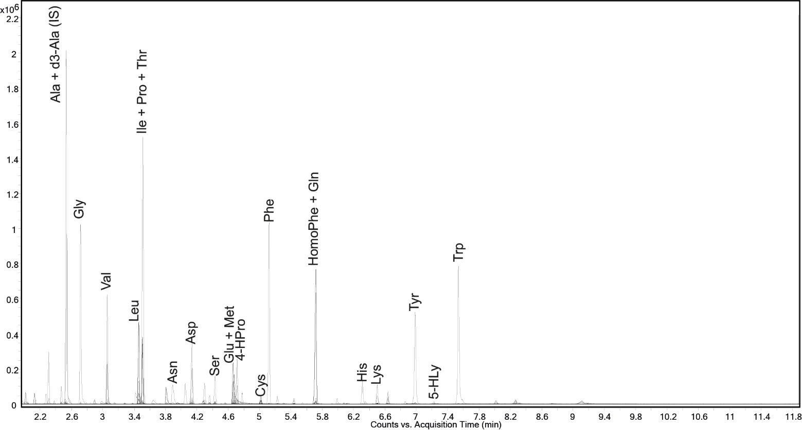
Relative abundance

Hint: Preparation of the calibration diagram and the units
A very convenient method of constructing the calibration plot is to express the units in absolute numbers (nmol/sample) rather than in units of molar concentration or mass concentration.
Example: The supplied SD1 solution is diluted 10 times and 10 µL of this diluted solution is taken for the Metamino reaction. This calibration point can be labeled as 1 nmol/sample.

Extracted ion chromatograms
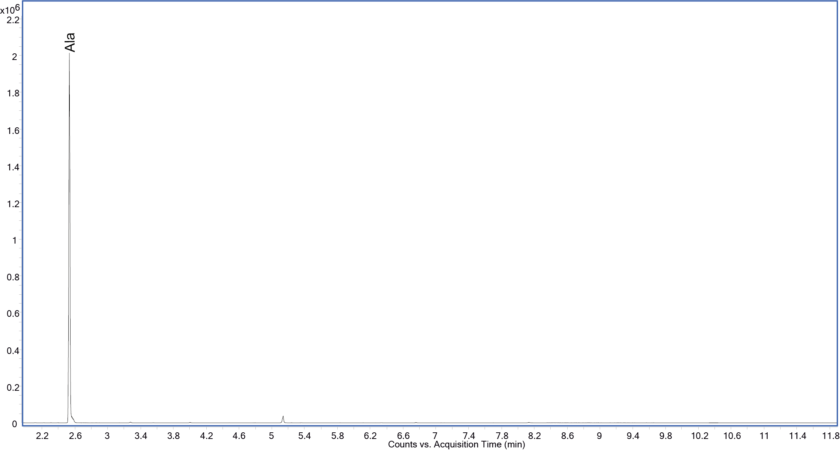
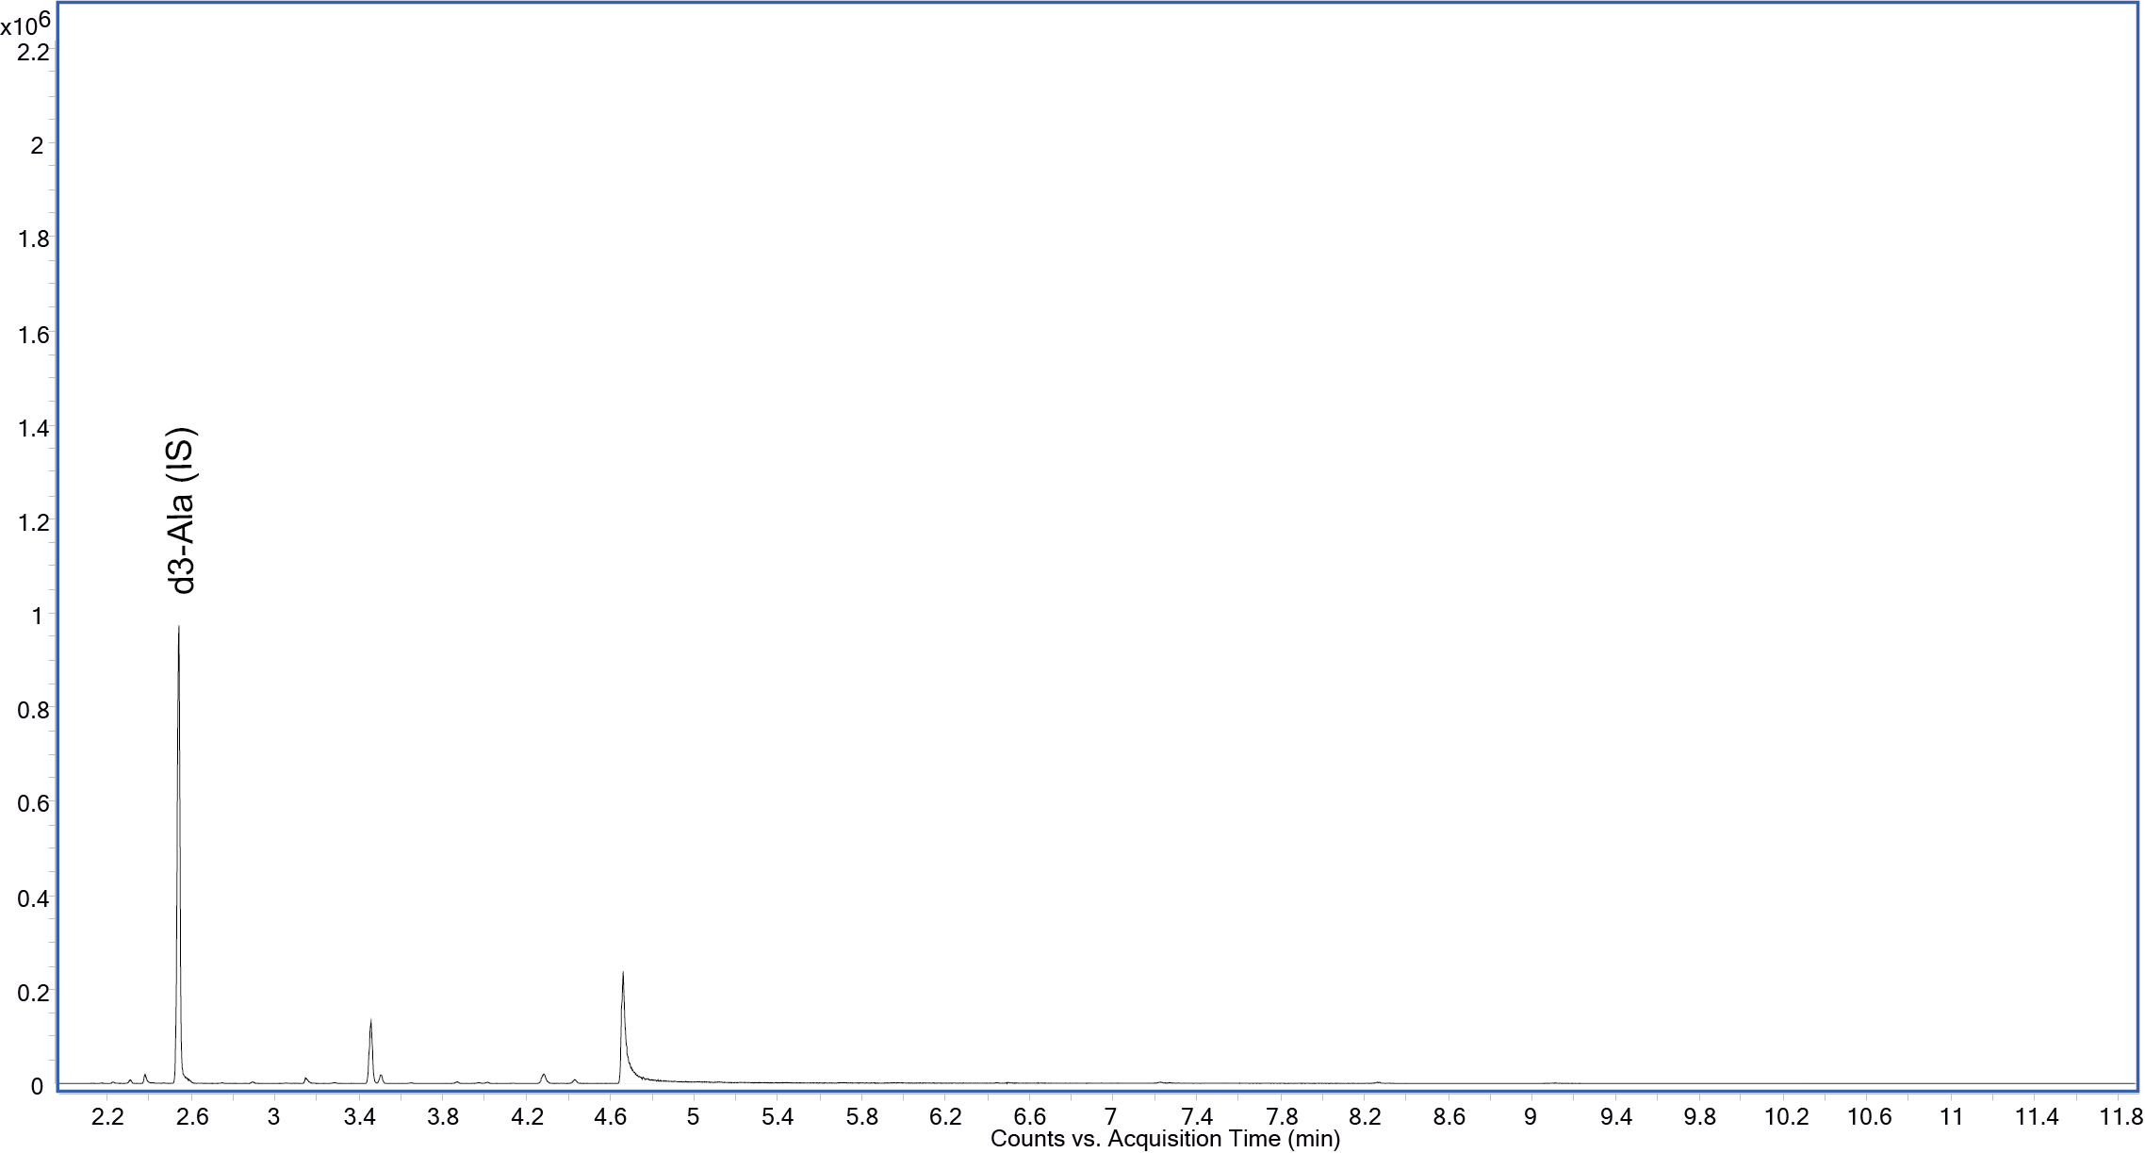

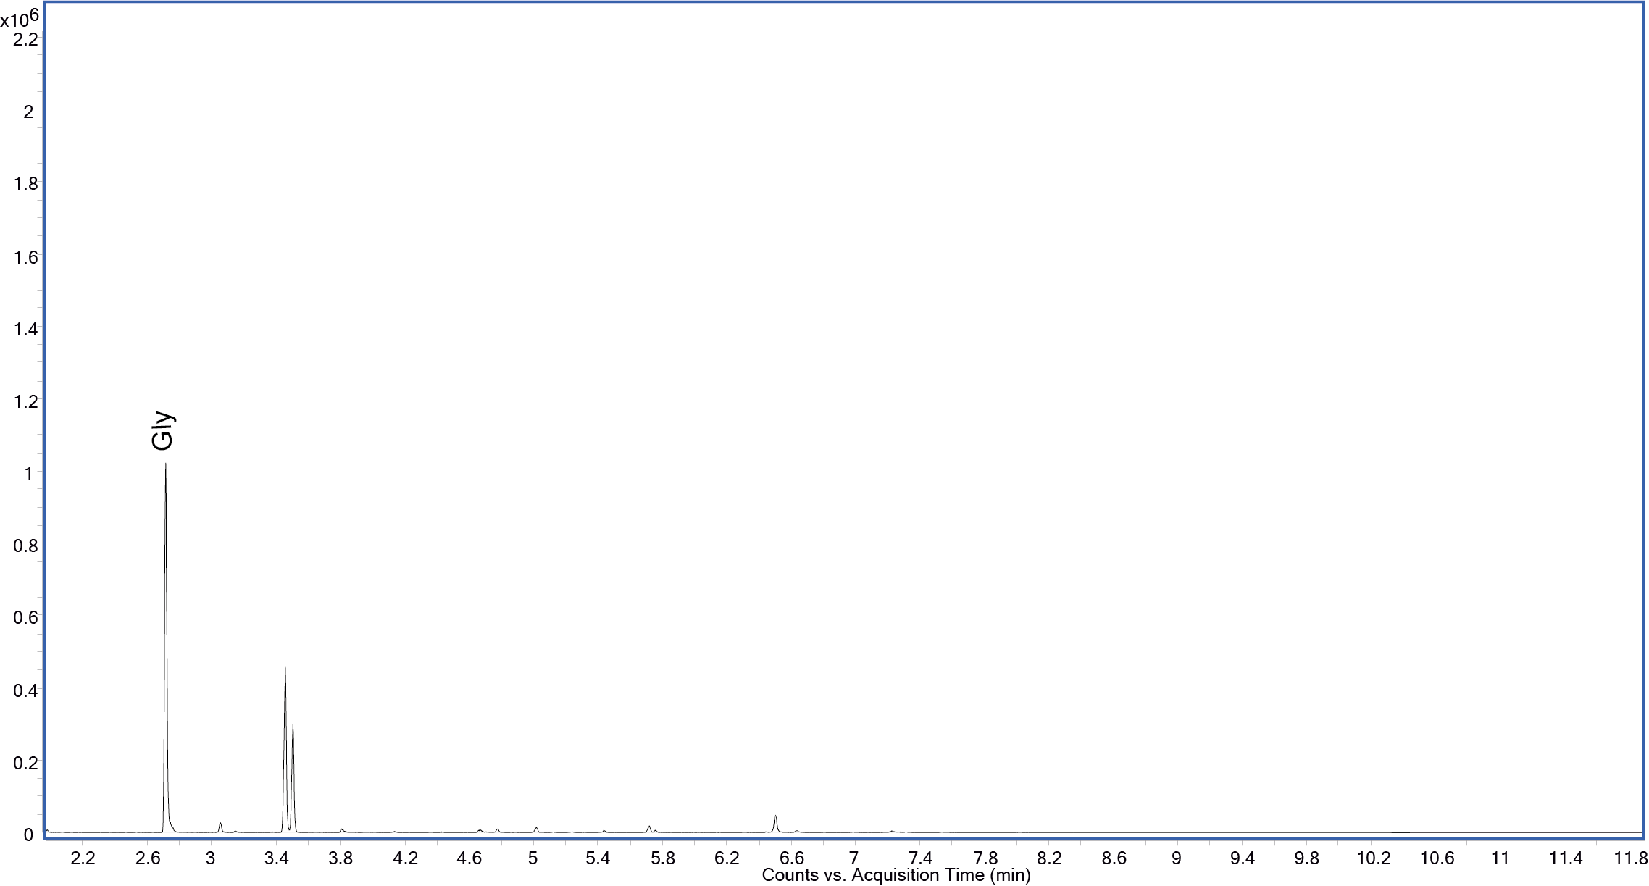
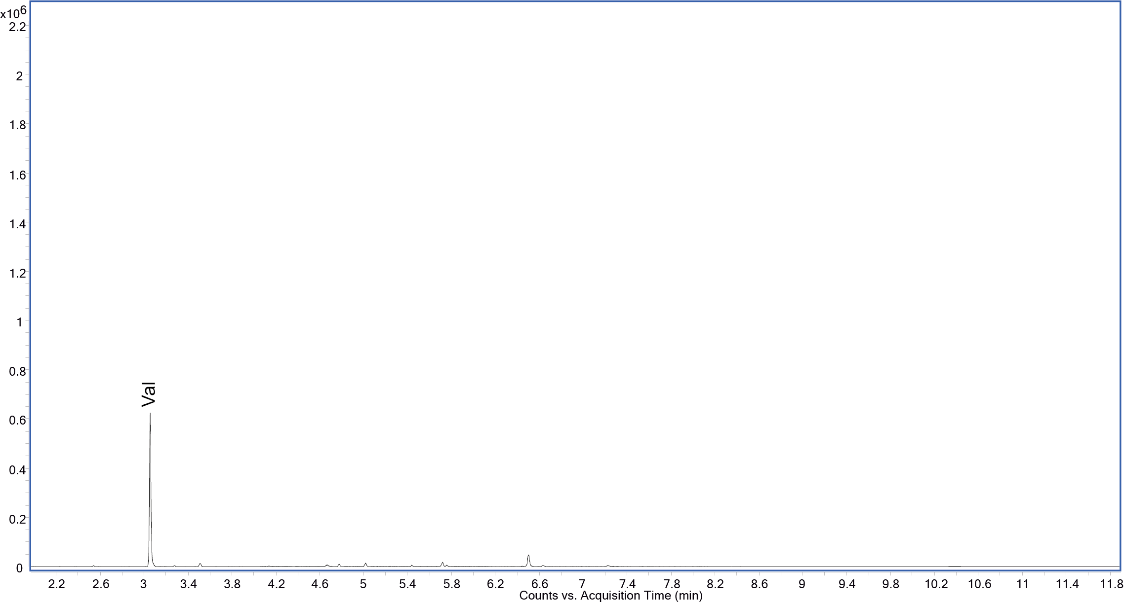
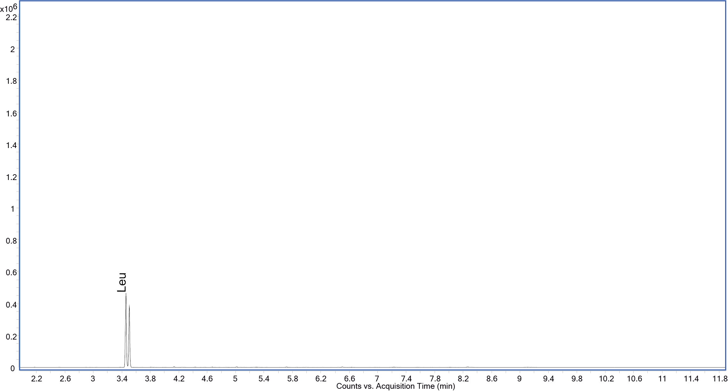
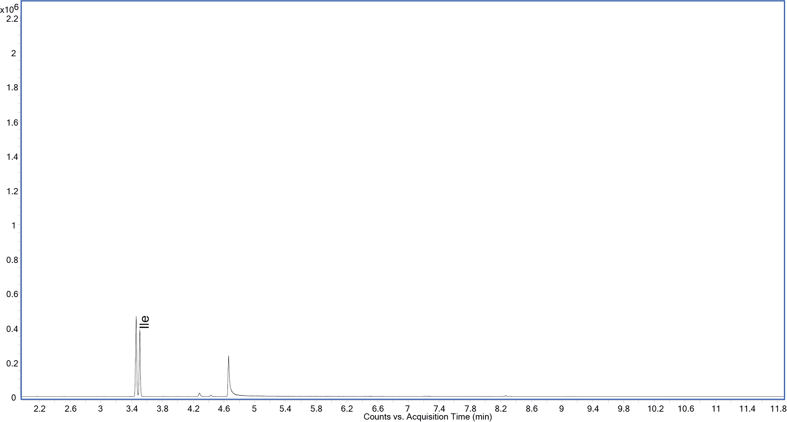
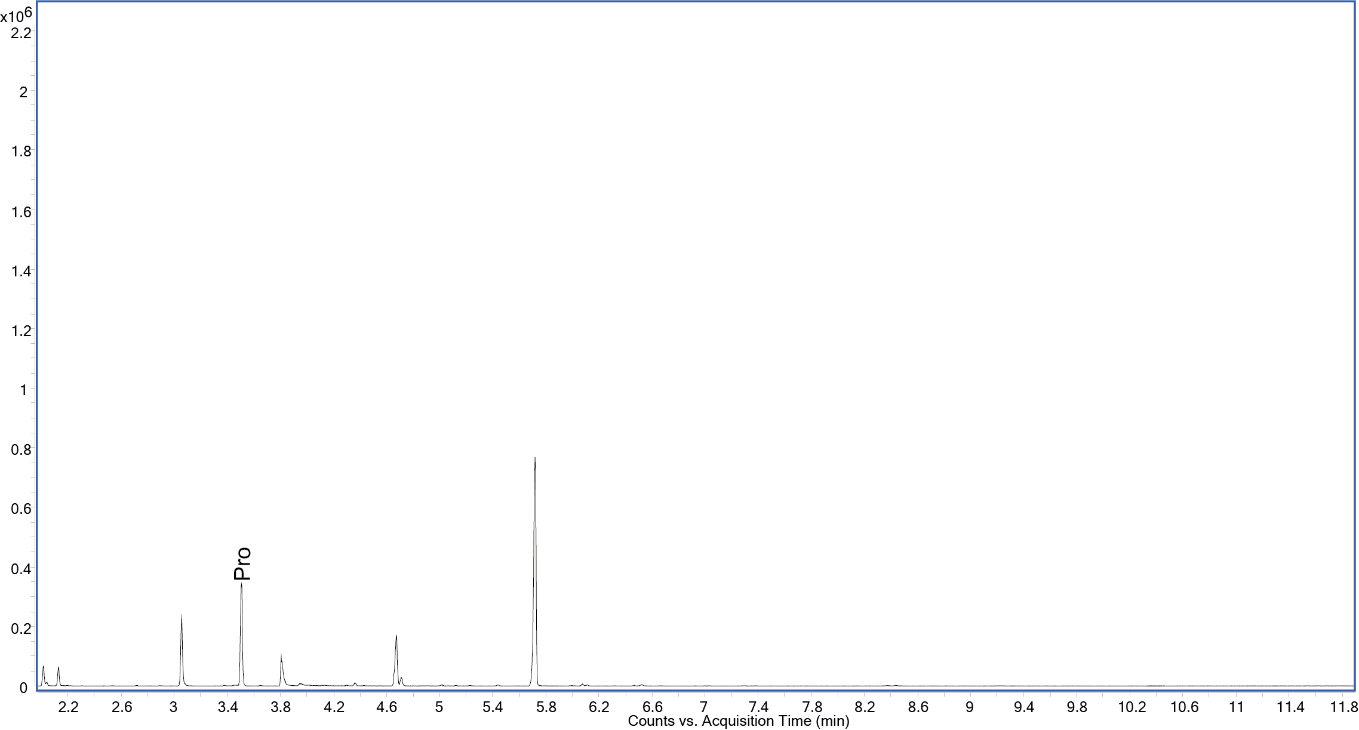
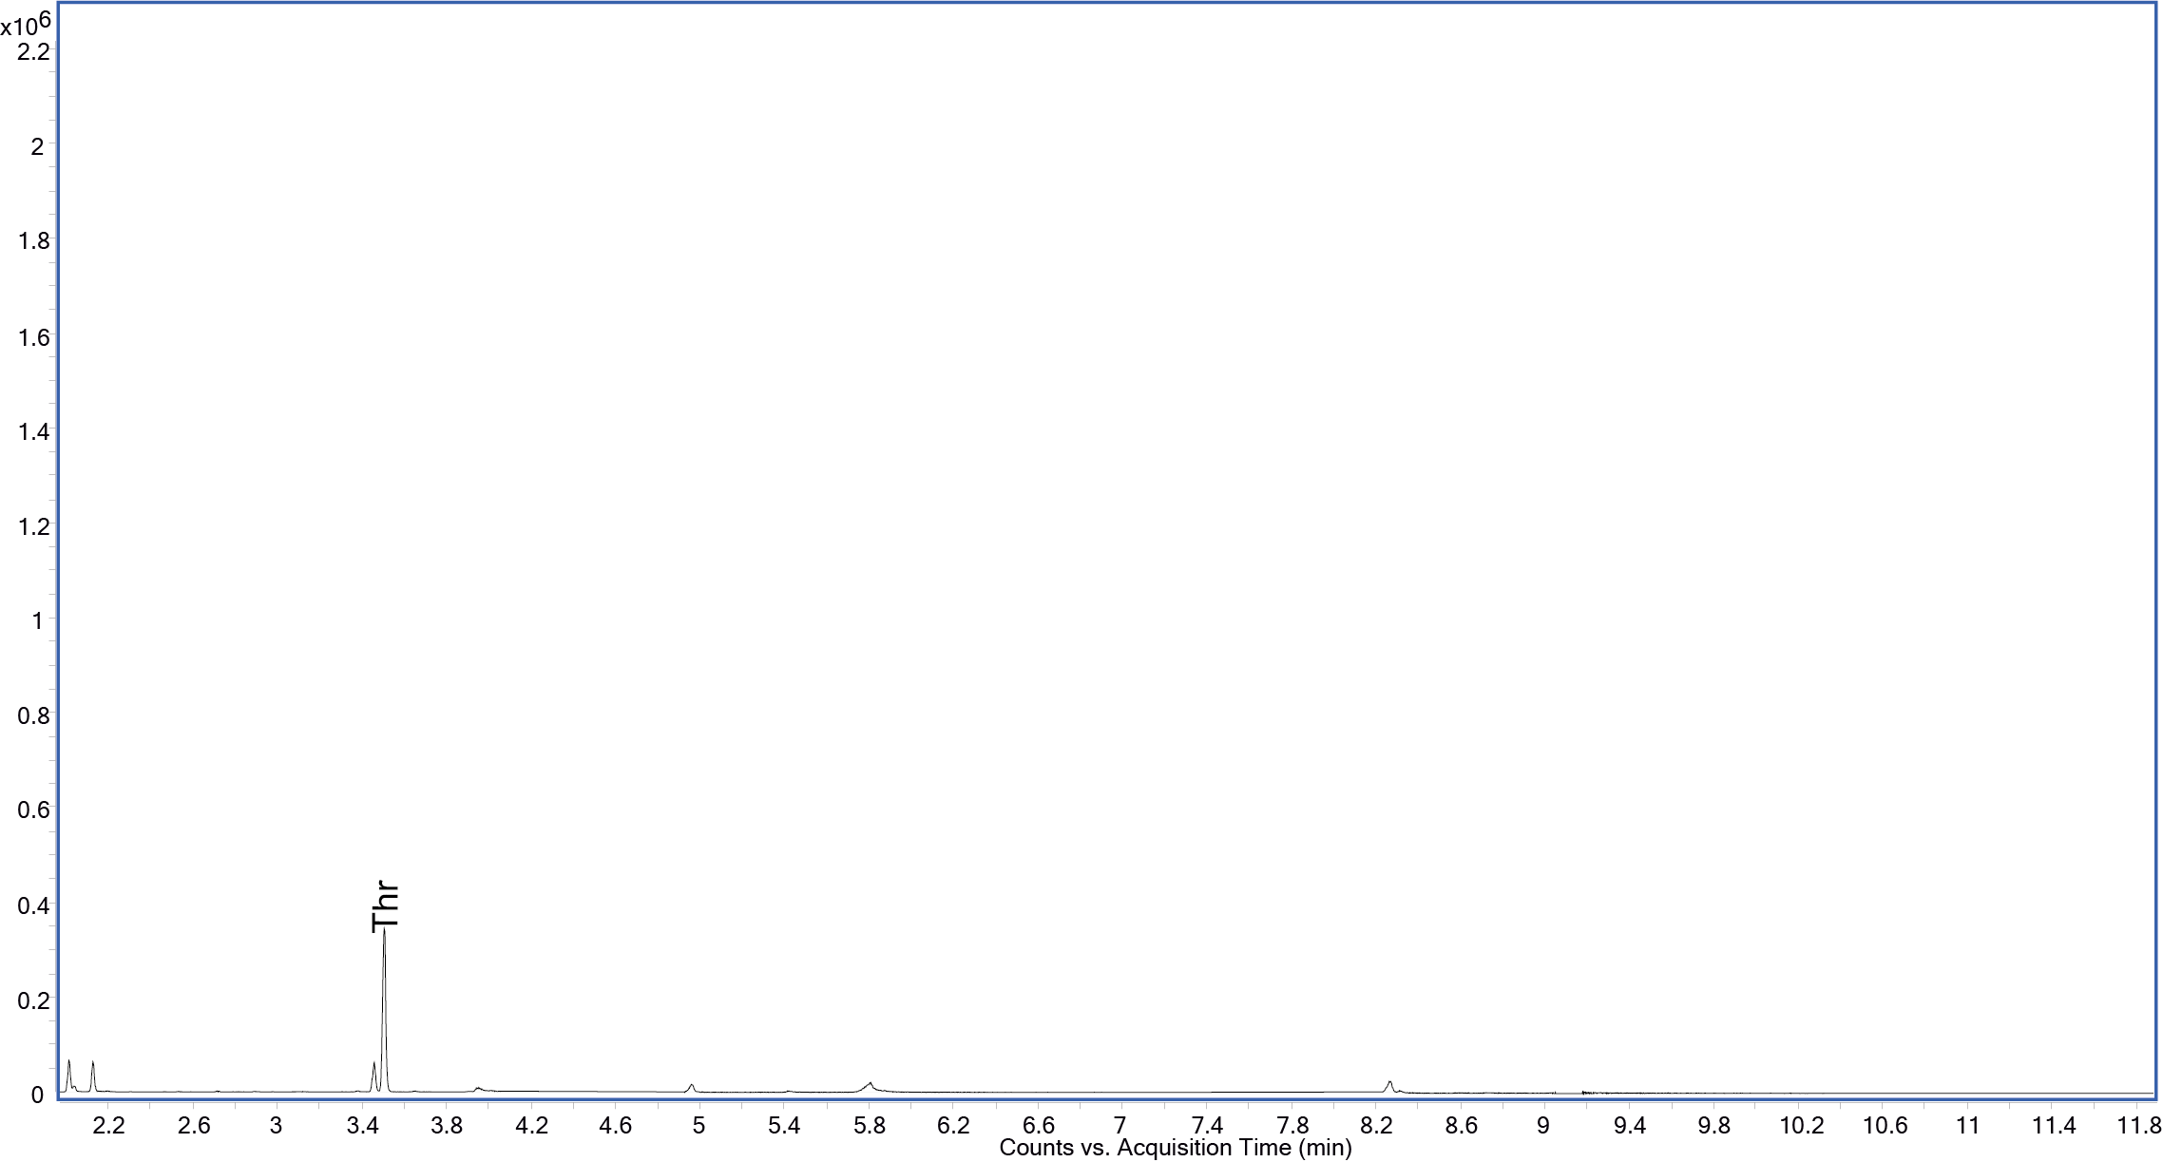
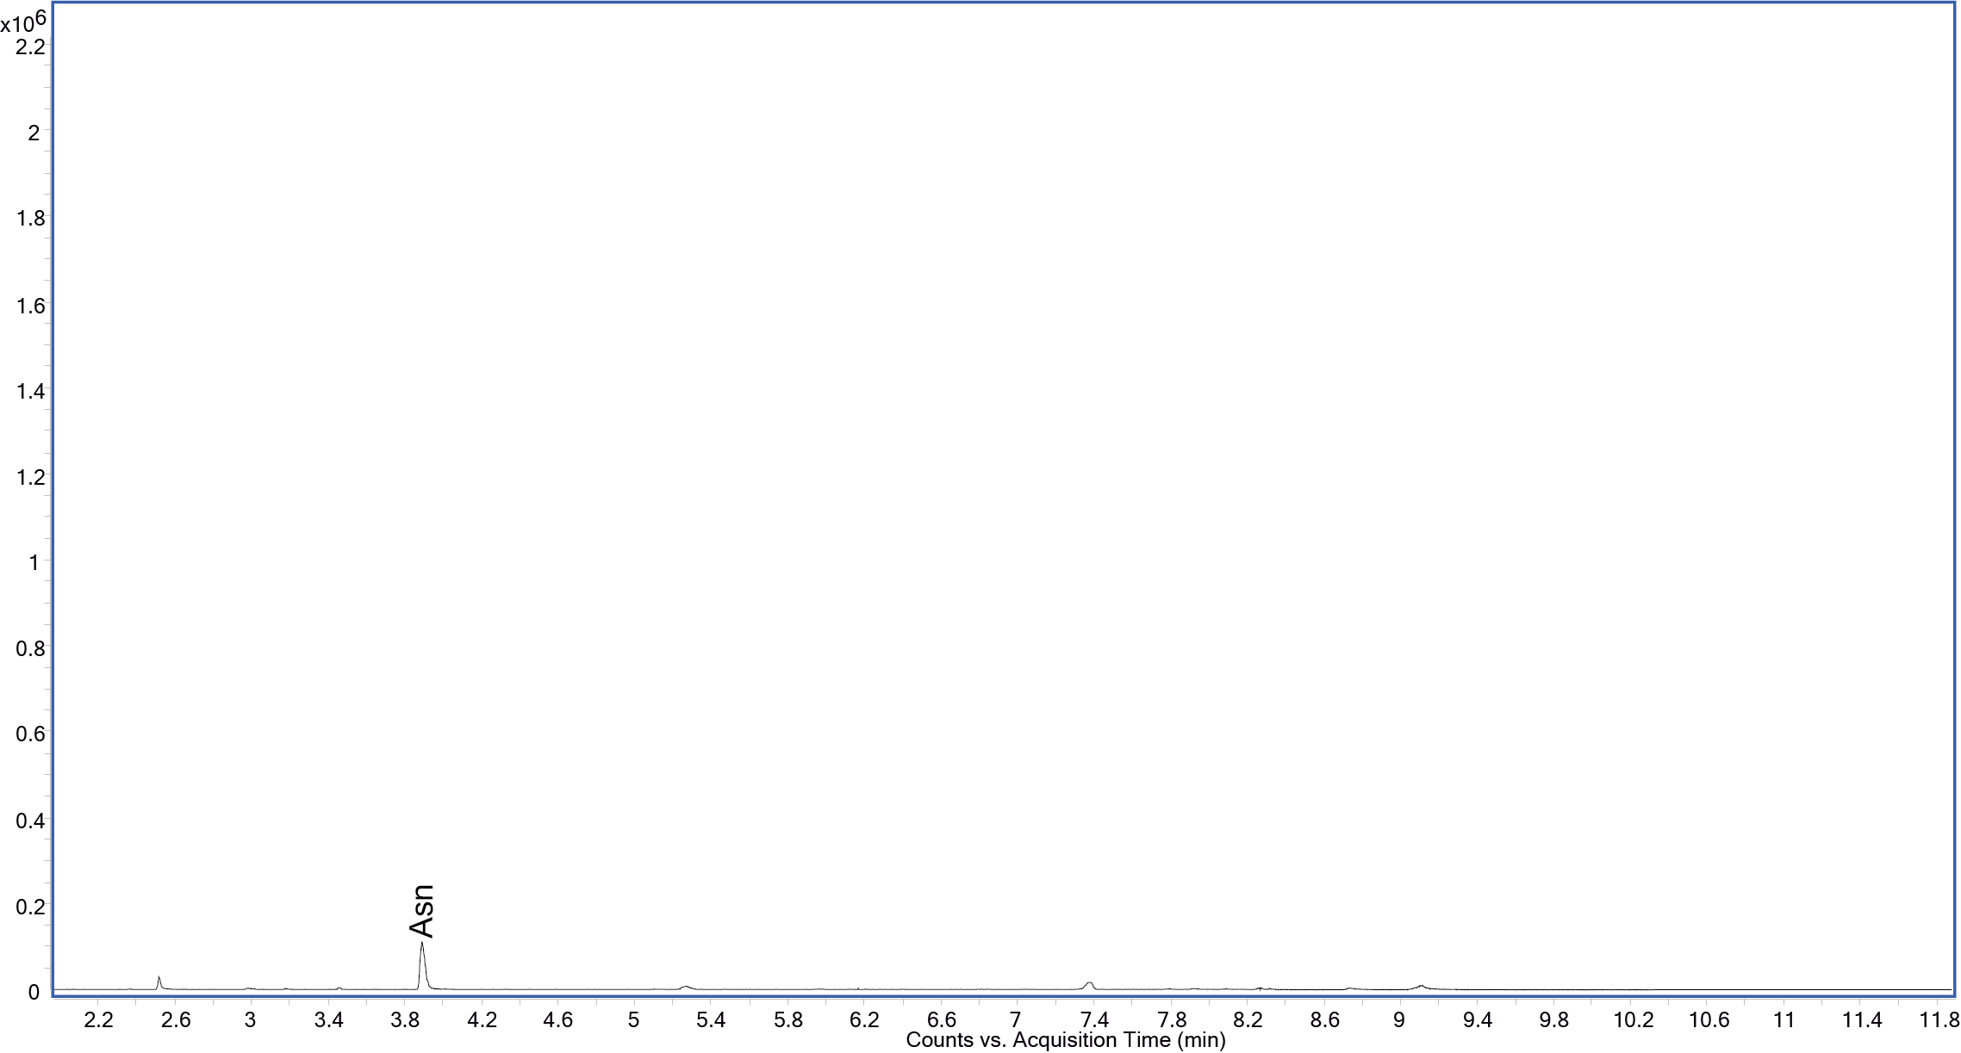
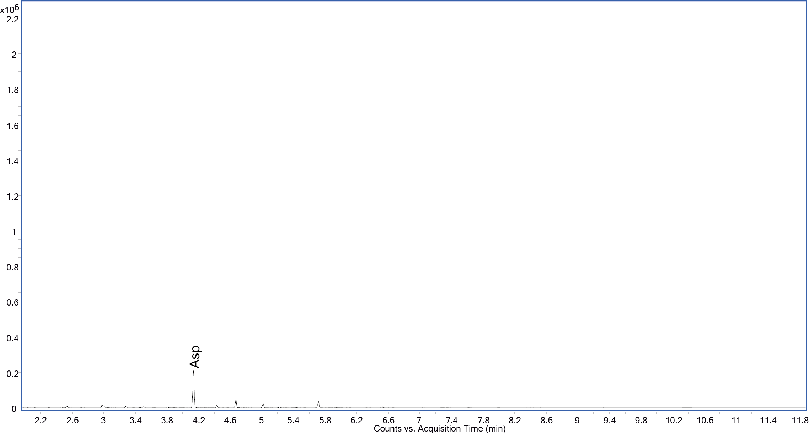
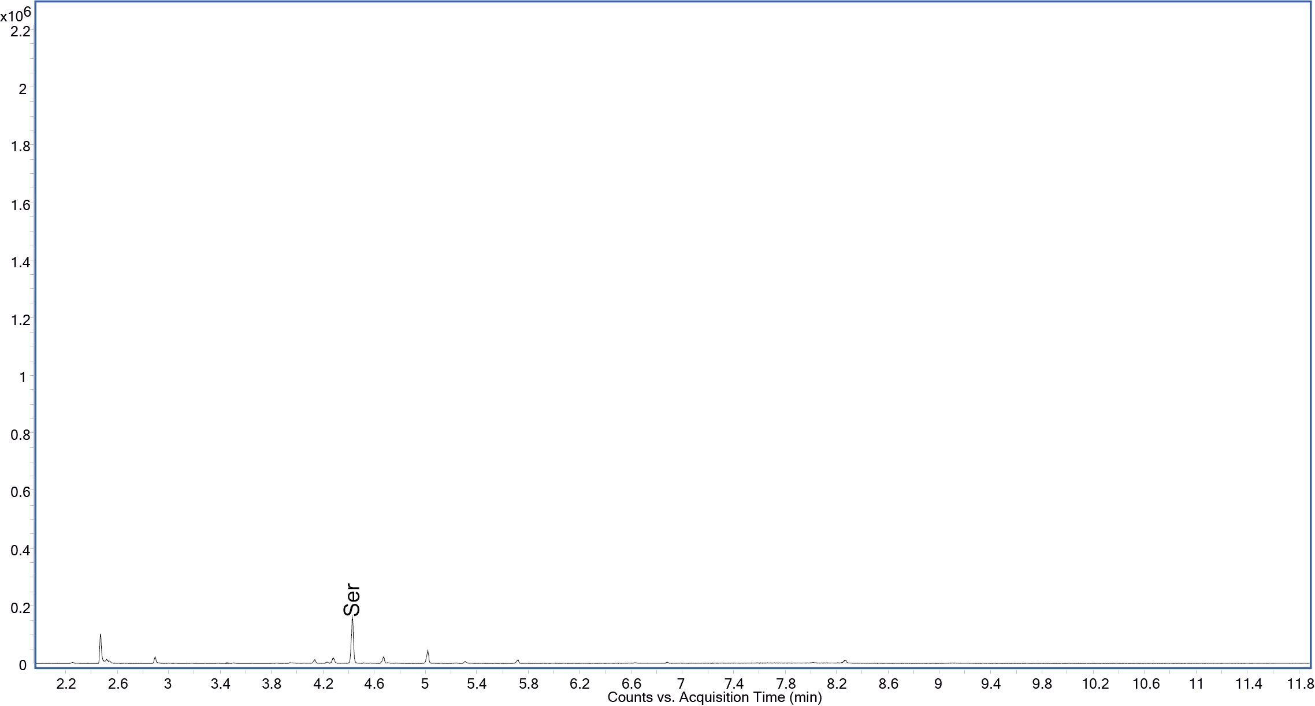
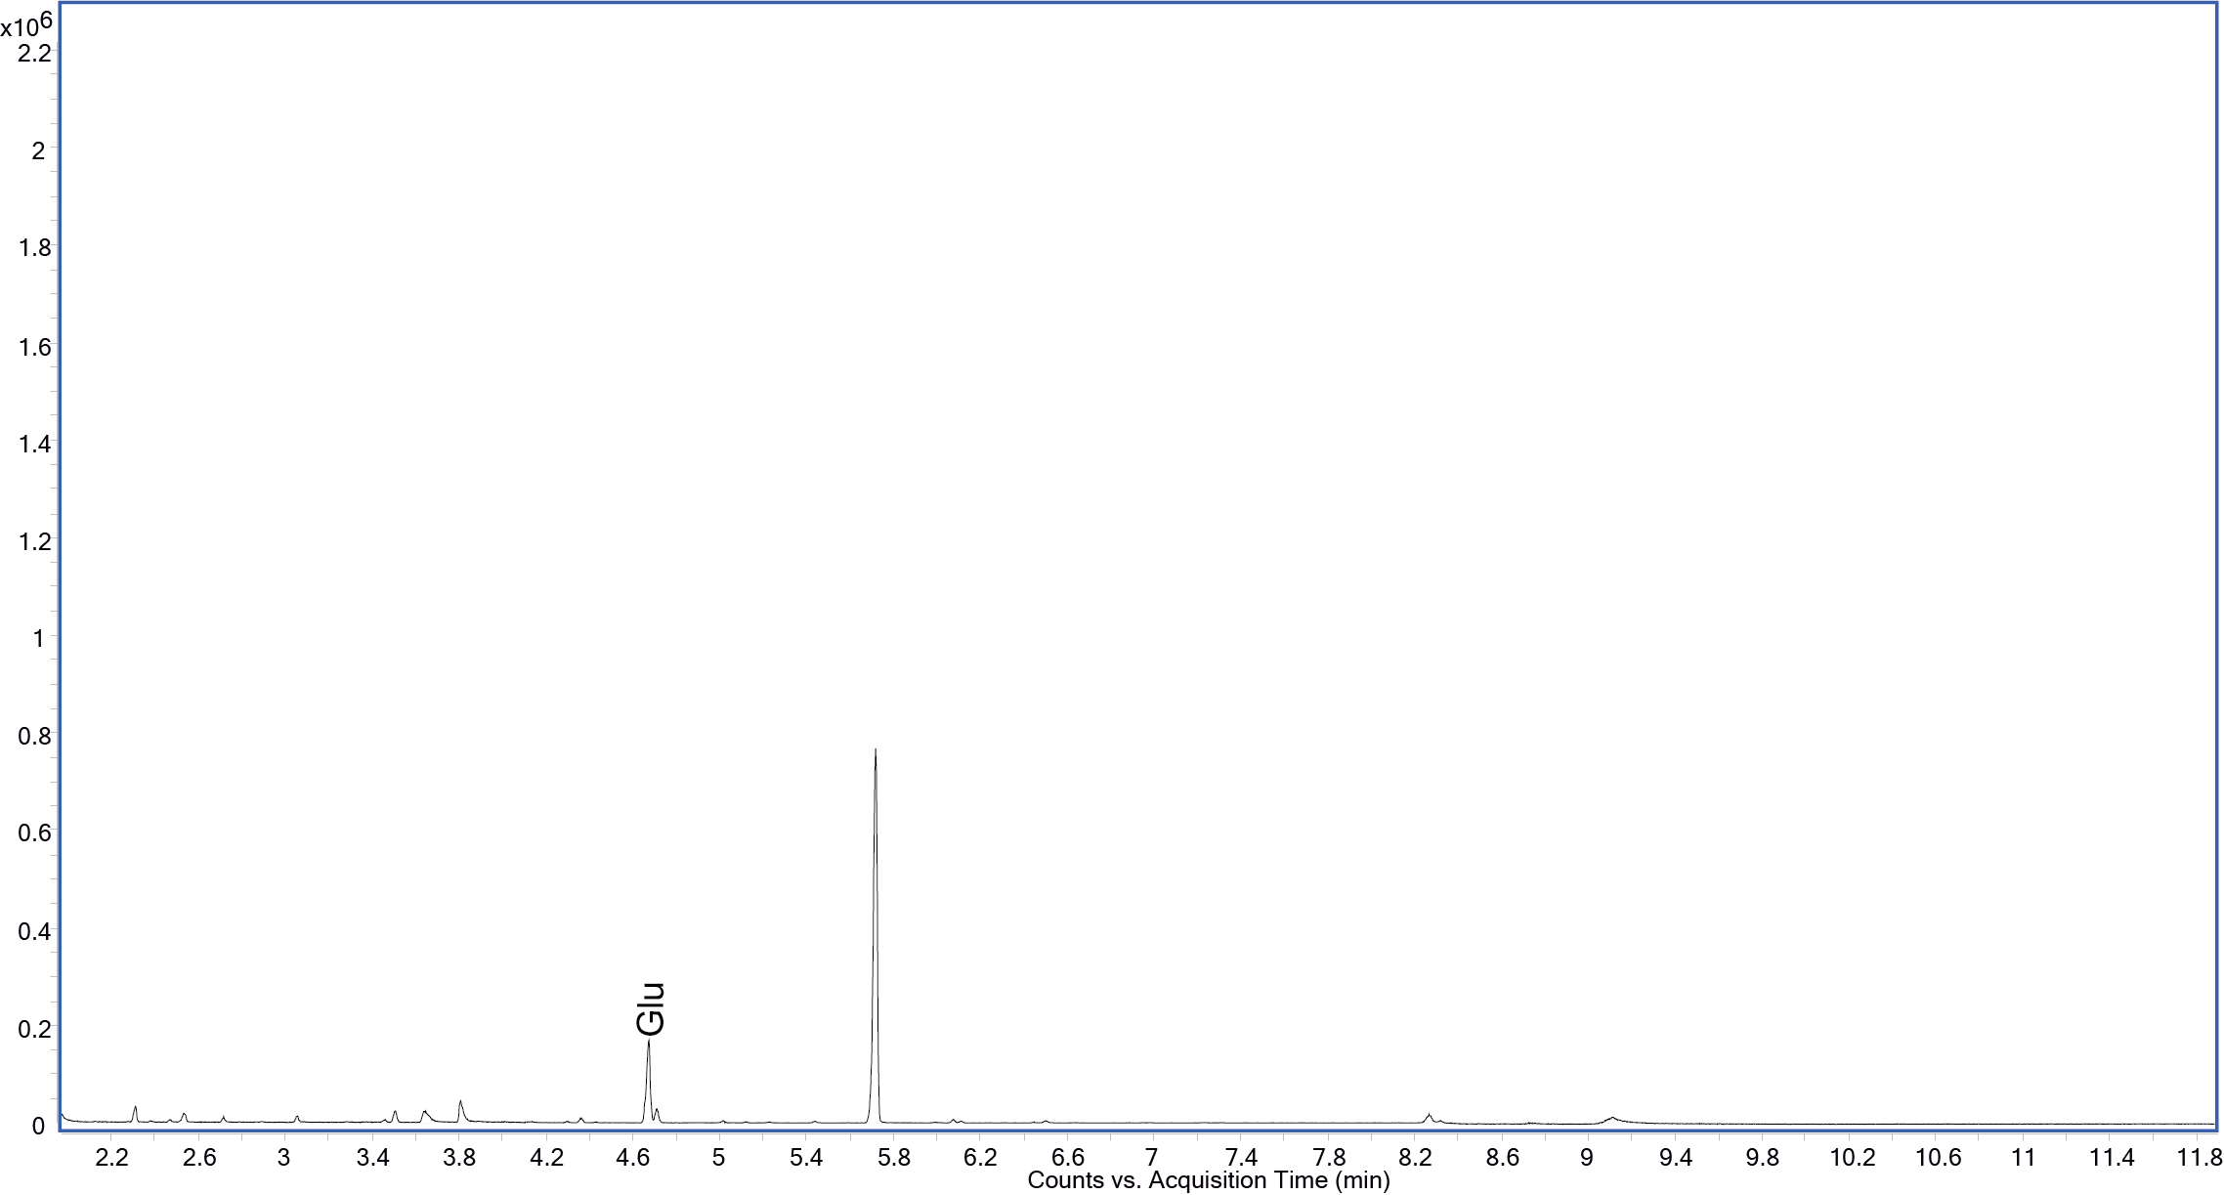
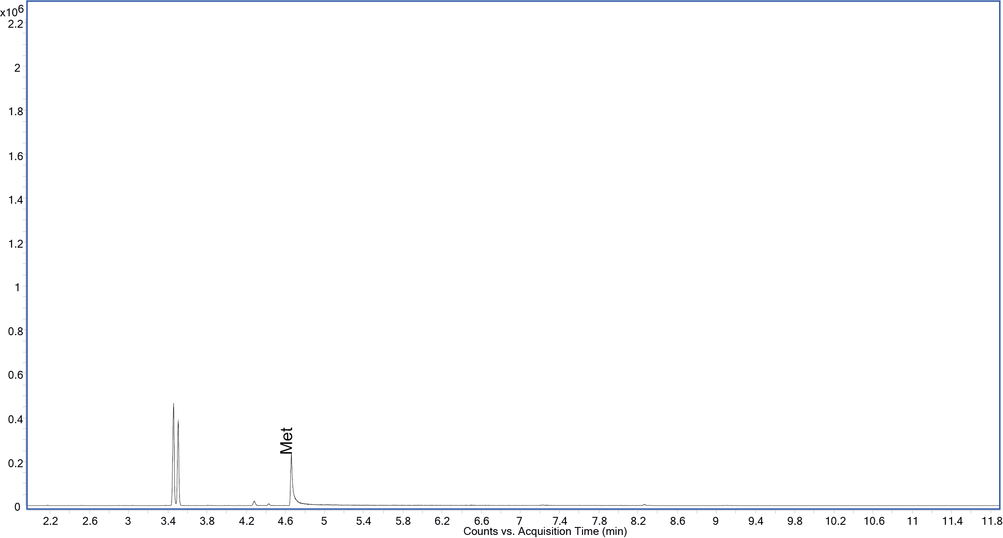
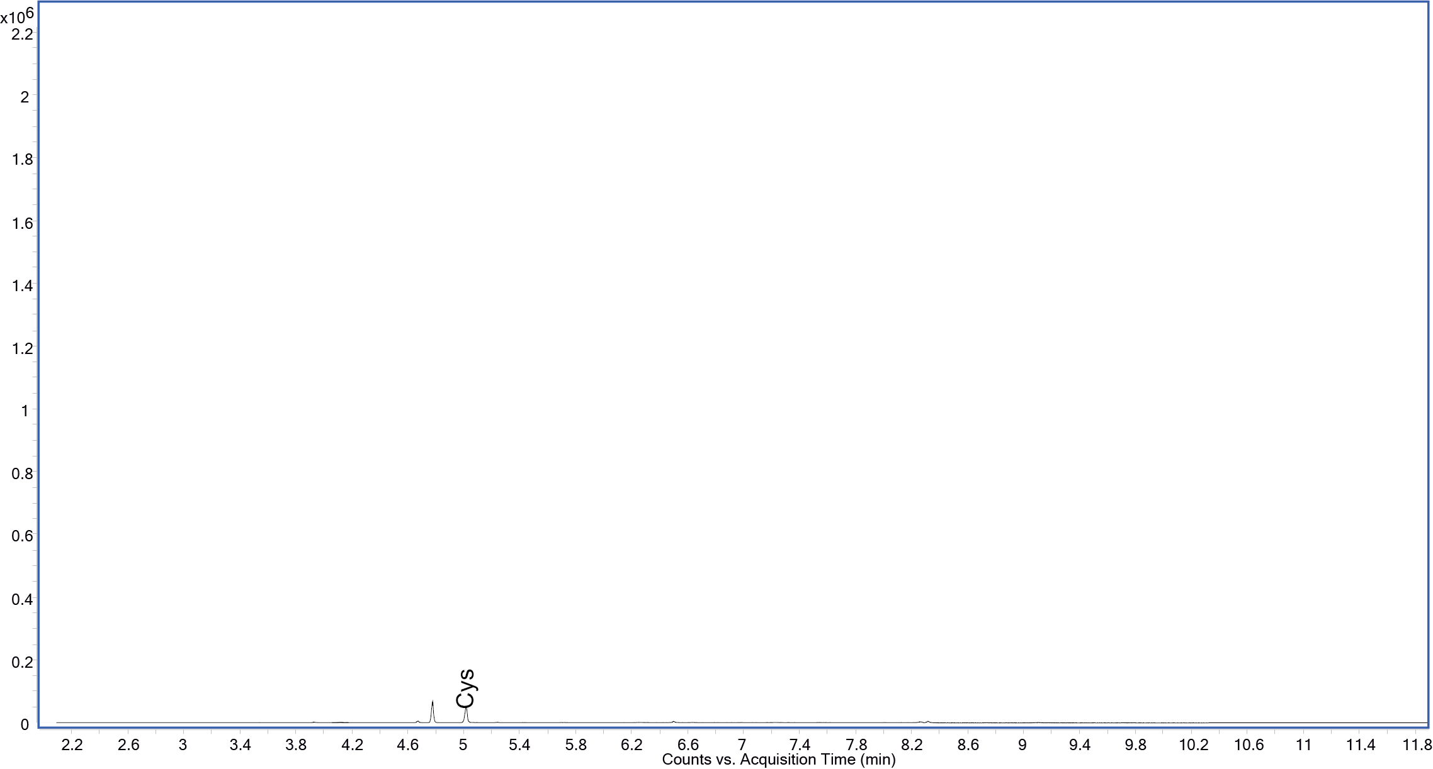
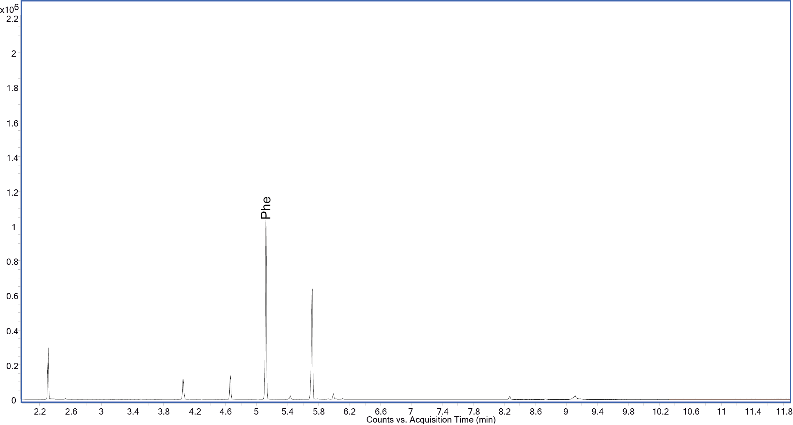
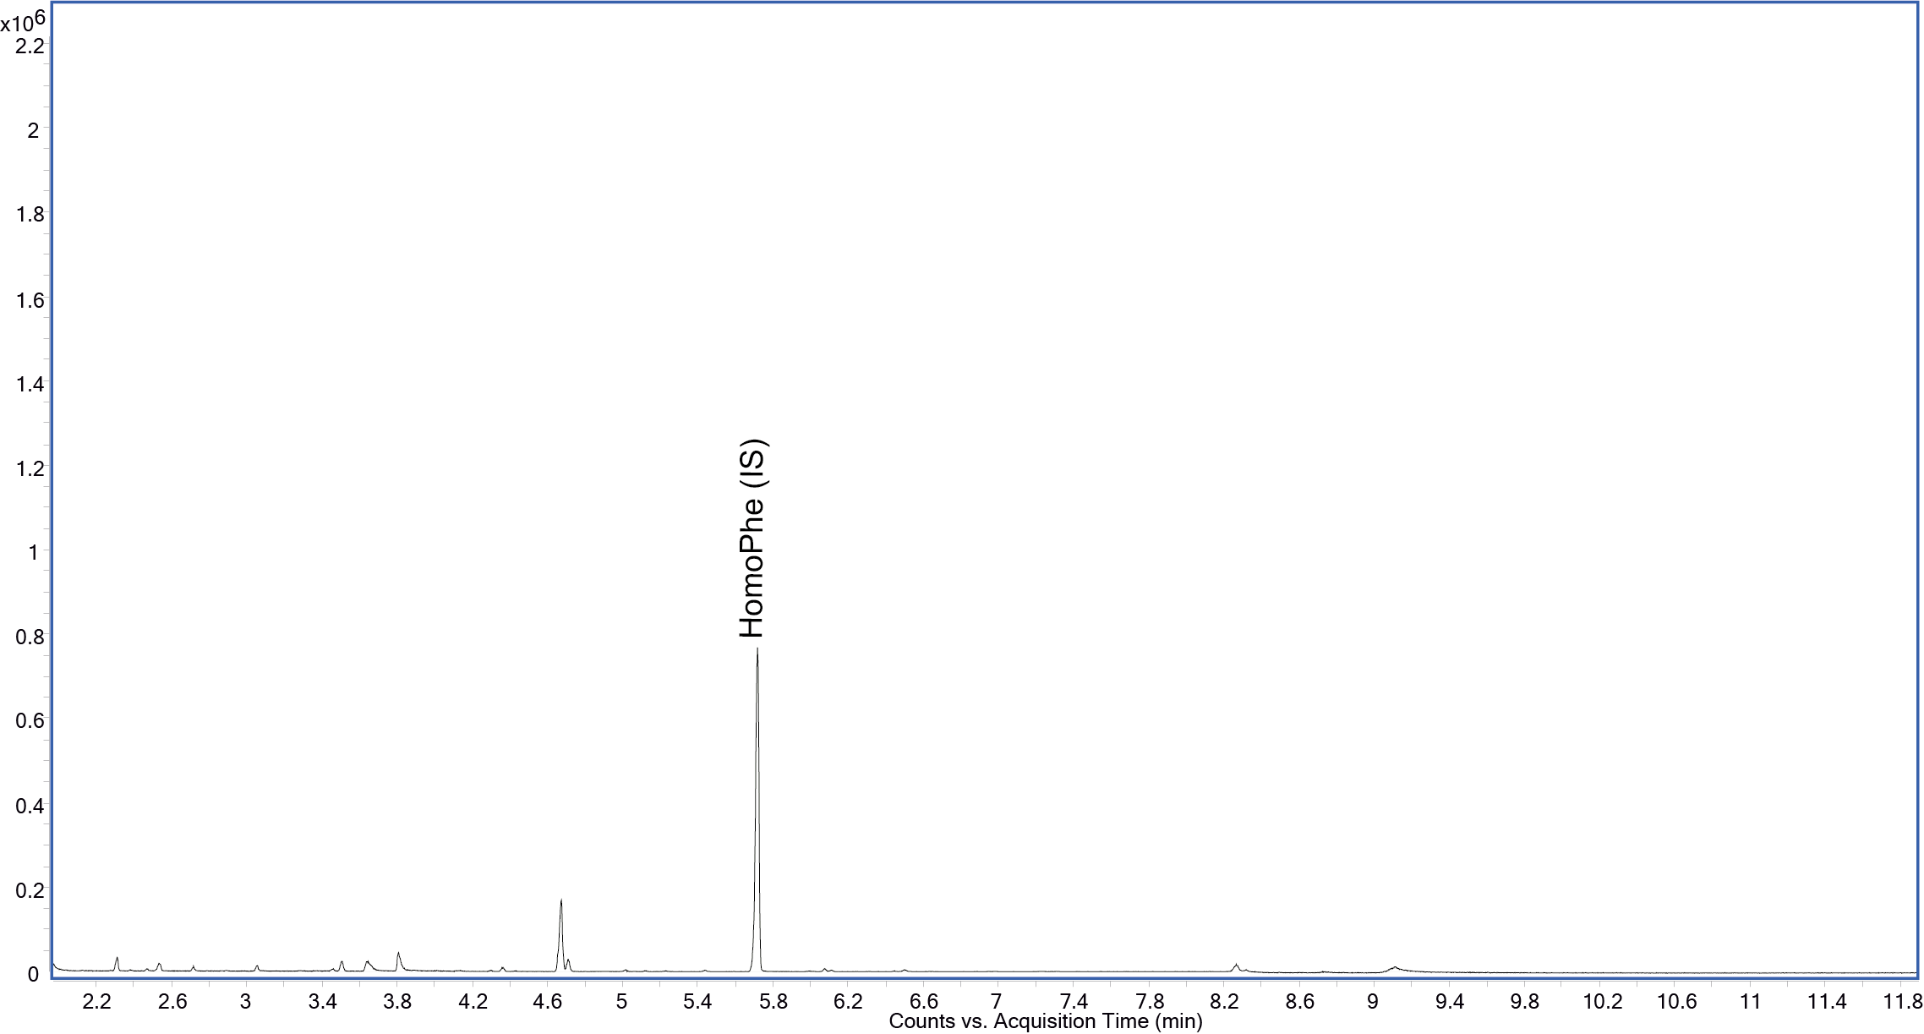
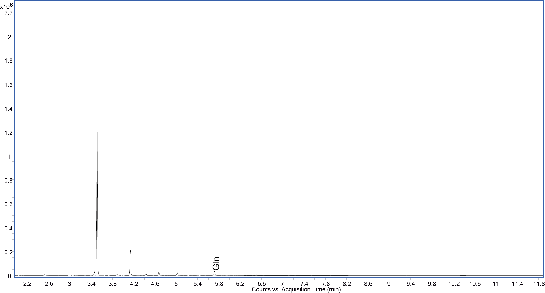
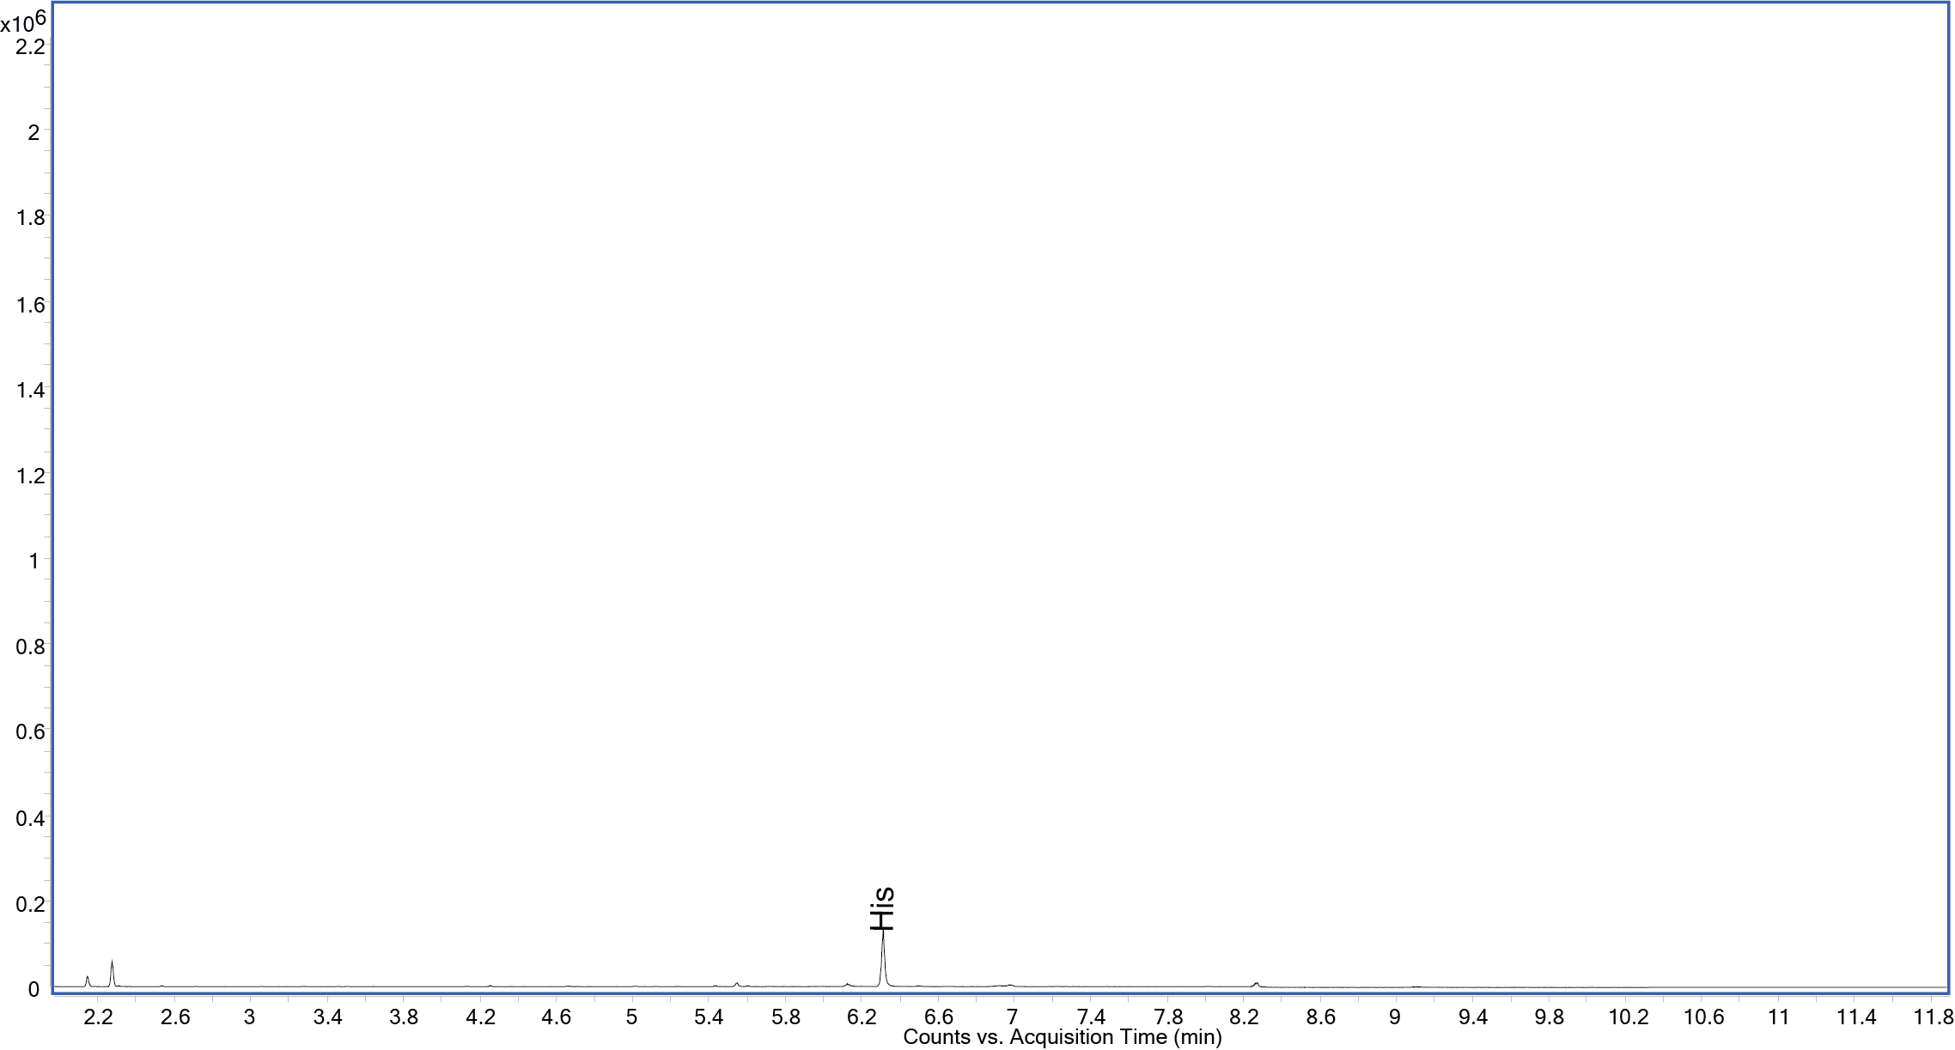
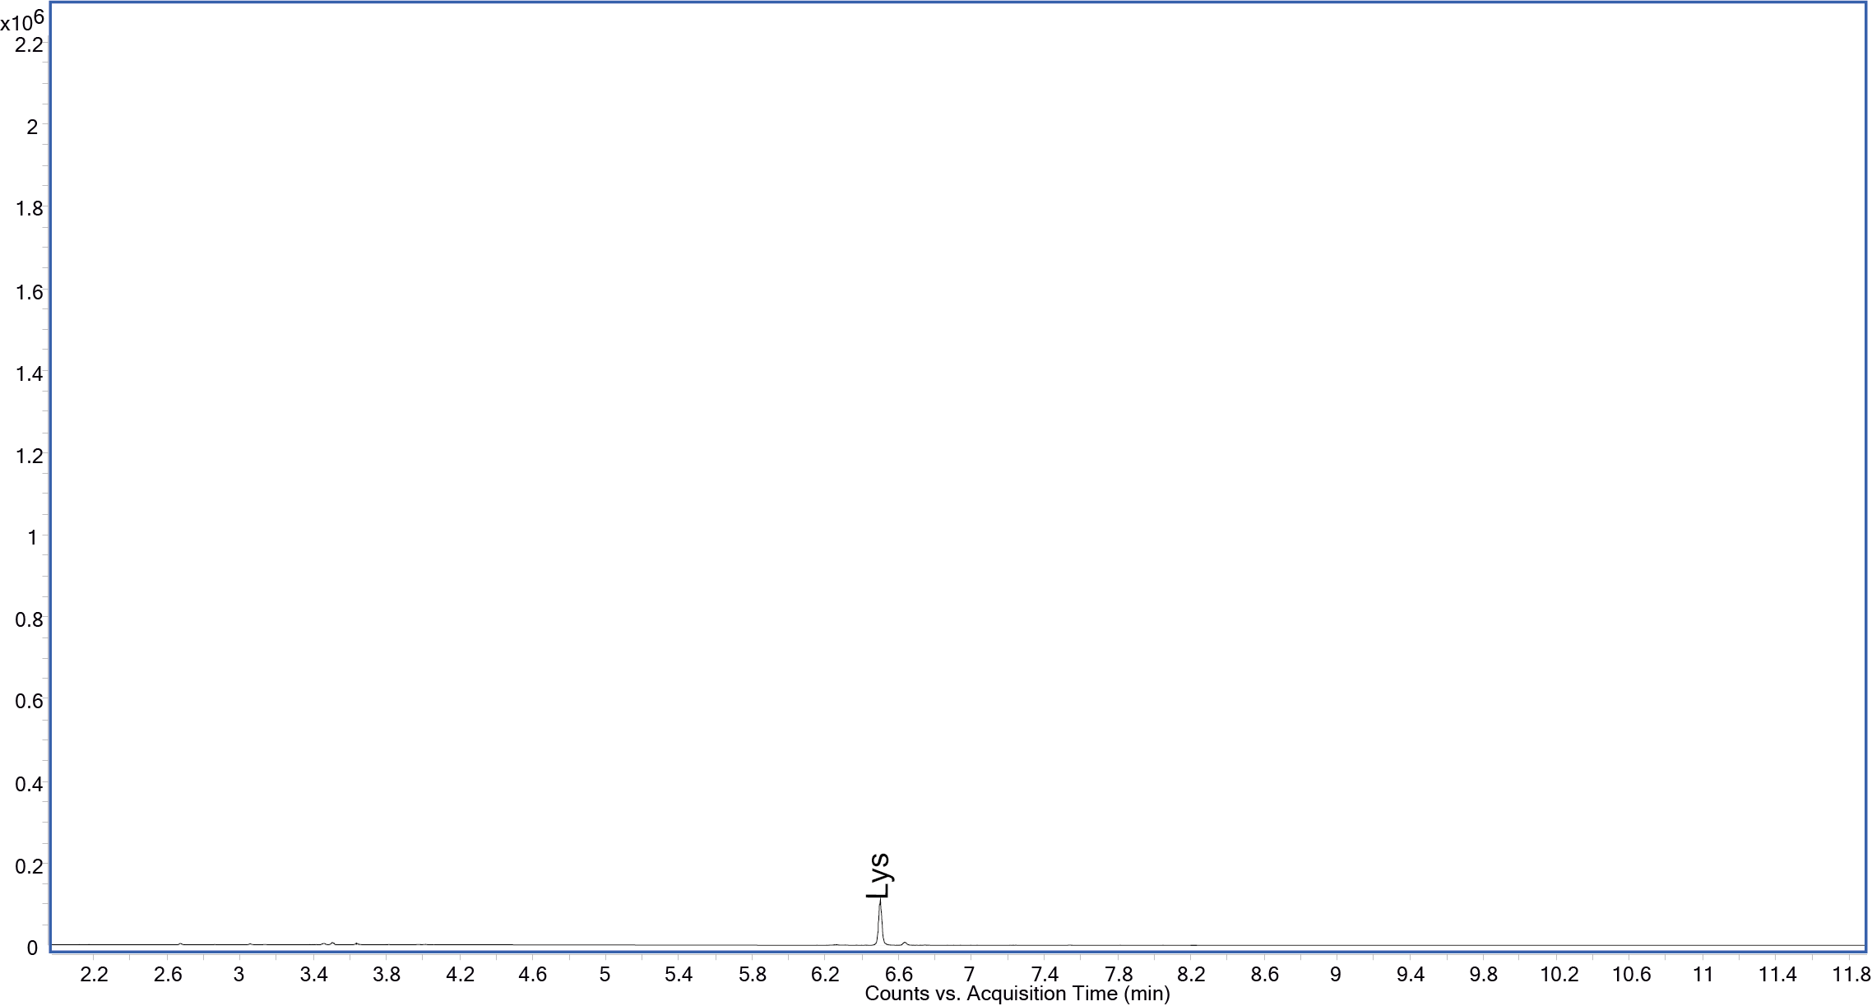
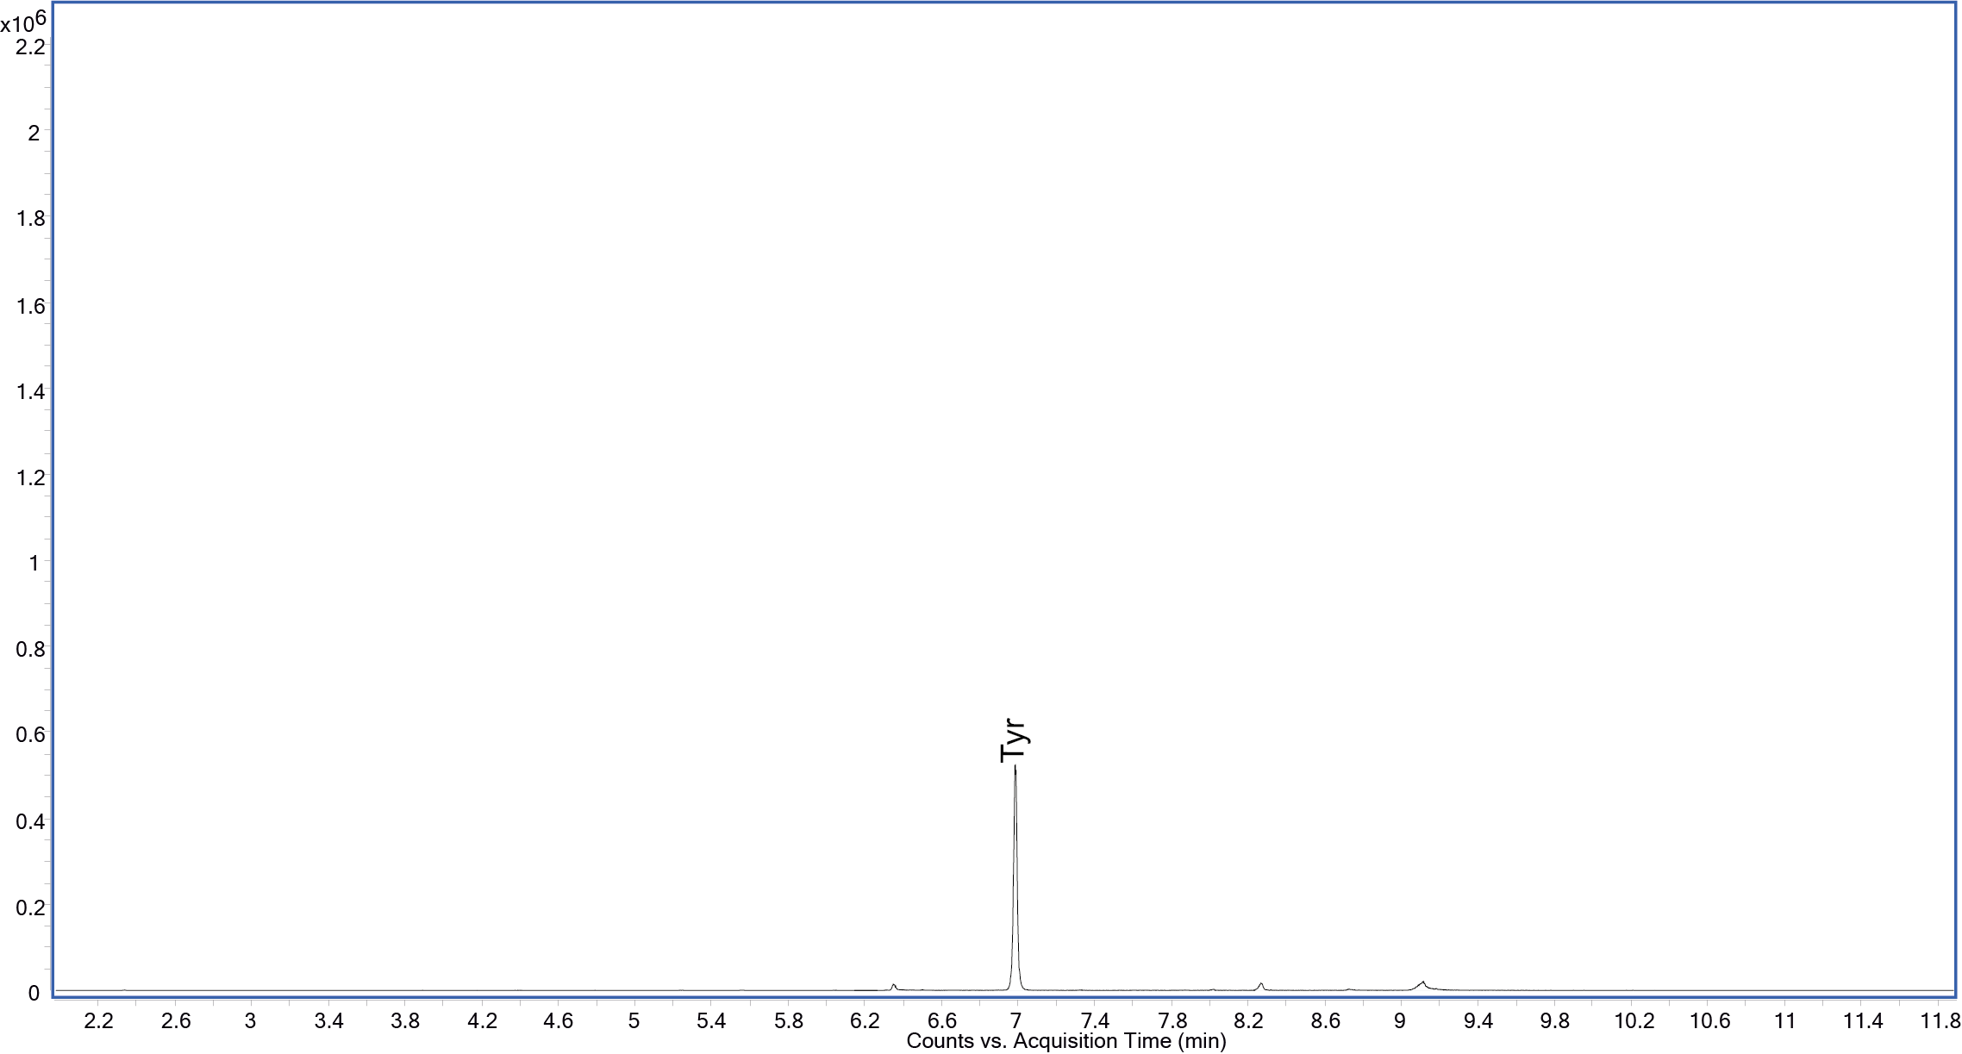
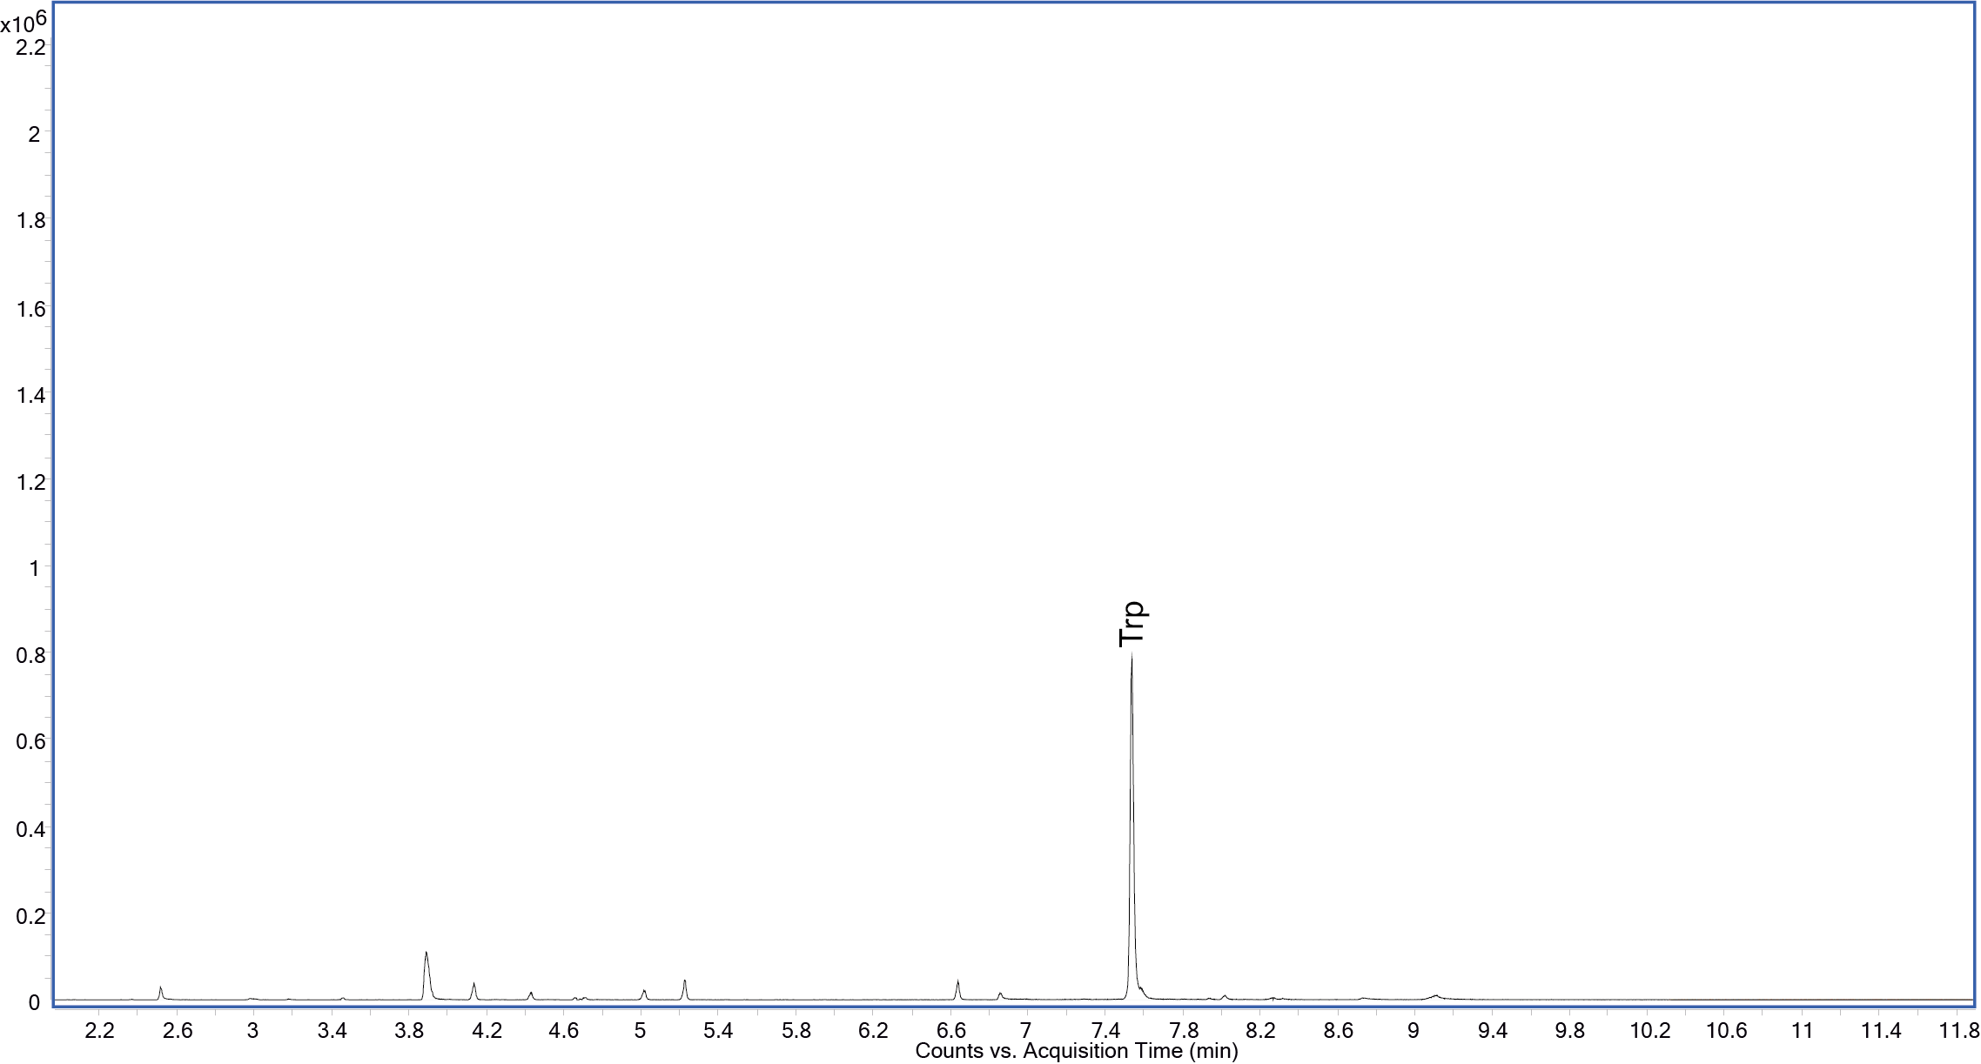
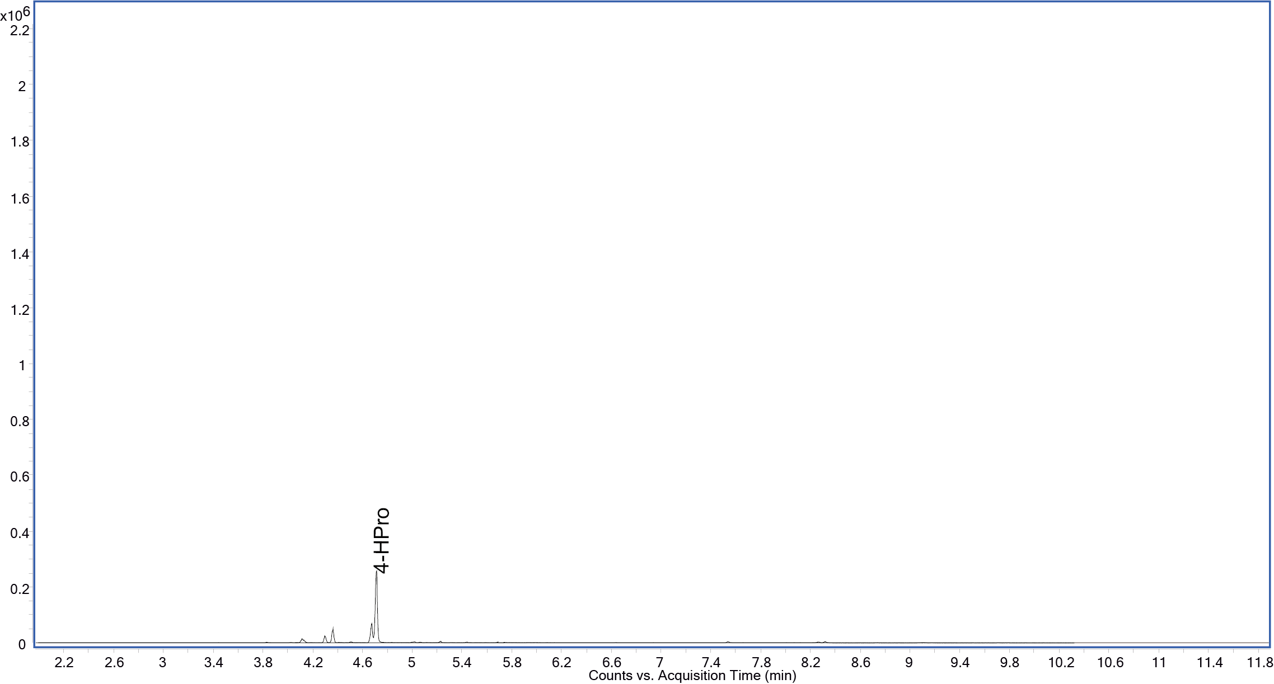
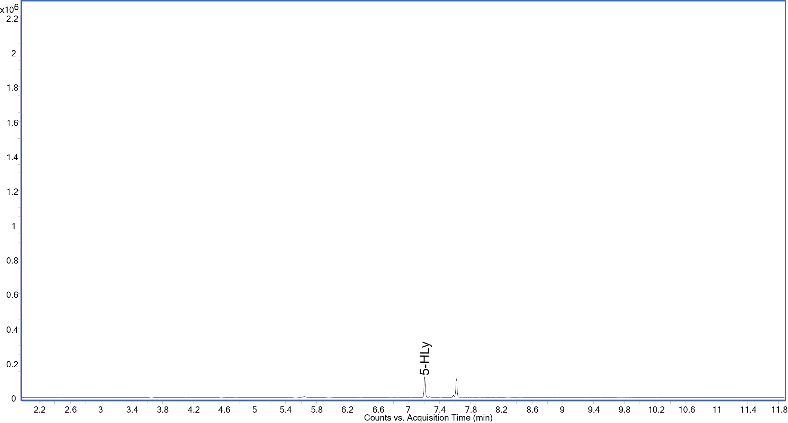

Sample Storage and Stability
Some amino acids are chemically unstable in physiological fluids (e.g. progressive decline of plasma glutamine and cystine over time) as well as in standard mixtures. Keep samples and standard mixtures in the fridge. Old amino acid standard mixtures and mixtures which have not been properly stored should not be used for instrument calibration. Order fresh mixtures from Chromservis (see ordering information in Section 9).
Samples prepared by the procedure described in this manual may be stored for several days in a freezer prior to GC-MS analysis. Because sample preparation is rapid with this procedure, we recommend analysing freshly prepared samples.

Cleaning and Care of Supplies
Always tightly cap all vials containing standards and reagents, especially the Reagent (Derivatization) Solution (RDS) vial, when not in use to avoid evaporation of the solvent and alteration of the reagent composition.
After pipetting the reagent medium, the pipette tip should be immediately removed and disposed of to prevent pipette damage.

Quality Assurance
All components of the MetAmino® analysis kit are subject to rigorous quality control testing. These measures help to ensure the best results. If poor results occur, please contact your Chromservis technical consultant or your local distributor.

Ordering Information
Item | p/n | Amount
MetAmino® sample preparation GC/MS start-up kit, CF  (for 100 samples) | MAK-5857-BA01 | 1 kit
MetAmino® sample preparation GC/MS basic kit, CF  (for 400 samples) – NOT AVAILABLE YET | MAK-5857-DA04 | 1 kit
MetAmino® sample preparation reagents kit  (for 100 samples) | MAK-5857-M002 | 1 set

Safety Data Sheets
The MetAmino® kit includes reagents classified according to regulation (EC) 1907/2006 (REACH). All Safety Data Sheets (SDS) are available to download using following QR code.

https://www.chromservis.eu/en/safety-data-sheets

Warranty
MetAmino® kit is for research use only, not for a use in diagnostic procedures (IVD).
Chromservis s.r.o. warrants that this kit shall perform in accordance with the specification set forth in the labelling and in this User manual. The MetAmino® kit is designed and intended for research purposes only, not for any clinical diagnostic purposes. This kit is dedicated to a use by properly qualified person only. This limited warranty is subject to the conditions mentioned below.
The limited warranty does not apply to any material deviation from the specifications, which result from:
- Improper use or from any purpose other than set forth in this User manual
- Faults and defects in any third-party component
- Modification of the MetAmino® kit components
- Any incorrect use when handling and storing the components of the kit

Manufacturer Contact
Chromsevis s.r.o.
Jakobiho 327
109 00 Praha 10 – Petrovice
The Czech Republic
www.chromservis.eu

The MetAmino® is a trademark registered by Chromservis s.r.o. Other trademarks and trade names may be used in this document to refer to either the entities claiming the marks and/or names or their products and are the property of their respective owners. We disclaim proprietary interest in the marks and names of others.
No part of this document may be copied, translated or changes without the written consent of Chromservis s.r.o.
Chromservis s.r.o. reserves the rights of change or improvement of this User manual.

